Long & low; or high & short; photoperiods and light differential growth yields and light-capture capacities of PhycoCyanin and PhycoErythrin-rich picocyanobacteria

Sylwia Śliwińska-Wilczewska1,2, Marta Konik3,4, Mireille Savoie1, Anabella Aguilera5,6, Naaman M. Omar1, and Douglas A. Campbell1,✉

1 Department of Biology, Mount Allison University, 53 York St., Sackville, NB, E4L 1C9, Canada  
2 Institute of Oceanography, University of Gdansk, 46 Pilsudskiego St, P81-378, Gdynia, Poland  
3 Department of Geography, University of Victoria, Victoria, BC, V8P 5C2, Canada  
4 Institute of Oceanology, Polish Academy of Sciences, 81-712 Sopot, Poland  
5 Department of Biology and Environmental Science, Centre for Ecology and Evolution in Microbial Model Systems (EEMiS), Linnaeus University, Kalmar, Sweden  
6 Department of Aquatic Sciences and Assessment, Swedish University of Agricultural Sciences, Uppsala, Sweden (present address)

✉ Correspondence: [Douglas A. Campbell <[dubhglascambeuil@gmail.com](mailto:dubhglascambeuil@gmail.com)>](mailto:dubhglascambeuil@gmail.com)

# 

# Supporting Information

**Tab.1.** Linear regression, coefficient of determination (R square), Pearson correlation coefficients (R), and *p*-value used to calculate the pigment content (µg mL−1) of two PhycoCyanin(PC)-rich cultures (056, 077) and two PhycoErythrin(PE)-rich cultures (048, 127) (Culture Collection of Baltic Algae) of *Synechococcus* sp. based on absorbance (A) measurements.

| Pigment | Abs | Linear_regression | R_square | R | *p*_value |
| --- | --- | --- | --- | --- | --- |
| Chl *a* | 665 | Chla µg/mL = (Abs665*13.411029)+0.154793 | 0.865 | 0.930 | 0.000 |
| Car | 480 | Car µg/mL = (Abs480*5.469880)+0.089971 | 0.791 | 0.890 | 0.000 |
| PE | 565 | PE µg/mL = (Abs565*26.760737)-0.143872 | 0.698 | 0.840 | 0.000 |
| PC | 620 | PC µg/mL = (Abs620*29.979866)-0.182611 | 0.807 | 0.900 | 0.000 |
| APC | 650 | APC µg/mL = (Abs650*3.873803)+0.021964 | 0.087 | 0.300 | 0.000 |

**Tab.2.** Three-way factorial ANOVA testing whether peak PAR, photoperiod, strain, and their interactions (Source_of_variation), significantly influence the chlorophyll specific exponential growth rate (µ; d−1), estimated from logistic fits of chlorophyll proxy OD680 – OD720 vs. cumulative diel PUR, for two PhycoCyanin(PC)-rich cultures (056, 077) and two PhycoErythrin(PE)-rich cultures (048, 127) (Culture Collection of Baltic Algae) of *Synechococcus* sp., grown at 30, 90, 180, 300, 600, or 900 peak PAR µmol photons m−2s−1; and photoperiods of 8, 12, 16, or 24 h. Df – degrees of freedom; Sum Sq – sum of squares; Mean Sq – mean sum of squares; *F*_value – Fisher's F-test statistic; *p*_value - level of significance.

| Source_of_variation | Df | Sum Sq | Mean Sq | *F*_value | *p*_value |
| --- | --- | --- | --- | --- | --- |
| Par_ue | 5 | 0.049 | 0.010 | 3.276e+30 | 0.000 |
| Photoperiod | 3 | 0.076 | 0.025 | 8.367e+30 | 0.000 |
| Strain | 3 | 0.003 | 0.001 | 3.151e+29 | 0.000 |
| Par_ue:Photoperiod | 13 | 0.040 | 0.003 | 1.025e+30 | 0.000 |
| Par_ue:Strain | 15 | 0.007 | 0.000 | 1.593e+29 | 0.000 |
| Photoperiod:Strain | 9 | 0.004 | 0.000 | 1.306e+29 | 0.000 |
| Par_ue:Photoperiod:Strain | 39 | 0.017 | 0.000 | 1.434e+29 | 0.000 |
| Residuals | 88 | 0.000 | 0.000 | NA | N/A |

**Tab.3.** One-way ANOVA of a three parameter model (Harrison and Platt 1986) from pooled data (All) and data fit across different photoperiods (8, 12, 16, or 24) from chlorophyll specific exponential growth rate vs. cumulative diel PUR (Fit_model), for two PhycoCyanin(PC)-rich cultures (056, 077) and two PhycoErythrin(PE)-rich cultures (048, 127) of *Synechococcus* sp., grown at 30, 90, 180, 300, 600, or 900 peak PAR µmol photons m−2s−1; and photoperiods of 8, 12, 16, or 24 h. Res.Df - residual degrees of freedom for each model; Res.Sum Sq - residual sum of squares for each model; *F*_value – Fisher's F-test statistic; *p*_value - level of significance.

| Strain | Fit_model | Res.Df | Res.Sum Sq | *F*_value | *p*_value |
| --- | --- | --- | --- | --- | --- |
| PC-rich_056 | 8_All | 41 | 8.063 | 1.807e+03 | 0.000 |
| PC-rich_056 | 12_All | 41 | 8.063 | 2.822e+01 | 0.001 |
| PC-rich_056 | 16_All | 41 | 8.063 | 8.566e+00 | 0.012 |
| PC-rich_056 | 24_All | 41 | 8.063 | 2.333e+01 | 0.001 |
| PC-rich_077 | 8_All | 41 | 3.015 | 6.193e+01 | 0.000 |
| PC-rich_077 | 12_All | 41 | 3.015 | 2.477e+01 | 0.001 |
| PC-rich_077 | 16_All | 41 | 3.015 | 1.855e+01 | 0.002 |
| PC-rich_077 | 24_All | 41 | 3.015 | 1.073e+01 | 0.007 |
| PE-rich_048 | 8_All | 41 | 6.731 | 1.443e+01 | 0.004 |
| PE-rich_048 | 12_All | 41 | 6.731 | 8.361e+01 | 0.000 |
| PE-rich_048 | 16_All | 41 | 6.731 | 8.403e+00 | 0.013 |
| PE-rich_048 | 24_All | 41 | 6.731 | 8.234e+01 | 0.000 |
| PE-rich_127 | 8_All | 41 | 13.016 | 1.453e+02 | 0.000 |
| PE-rich_127 | 12_All | 41 | 13.016 | 2.060e+03 | 0.000 |
| PE-rich_127 | 16_All | 41 | 13.016 | 6.908e+00 | 0.020 |
| PE-rich_127 | 24_All | 41 | 13.016 | 7.812e+01 | 0.000 |

**Tab.4.** One-way ANOVA of a three parameter model (Harrison and Platt 1986) from pooled data (All) and data fit across different peak PAR (30, 90, 180, 300, 600 together with 900) from chlorophyll specific exponential growth rate vs. cumulative diel PUR (Fit_model), for two PhycoCyanin(PC)-rich cultures (056, 077) and two PhycoErythrin(PE)-rich cultures (048, 127) of *Synechococcus* sp., grown at 30, 90, 180, 300, 600, or 900 peak PAR µmol photons m−2s−1; and photoperiods of 8, 12, 16, or 24 h. Res.Df - residual degrees of freedom for each model; Res.Sum Sq - residual sum of squares for each model; *F*_value – Fisher's F-test statistic; *p*_value - level of significance.

| Strain | Fit_model | Res.Df | Res.Sum Sq | *F*_value | *p*_value |
| --- | --- | --- | --- | --- | --- |
| PC-rich_056 | 30_All | 41 | 8.063 | 1.807e+03 | 0.000 |
| PC-rich_056 | 90_All | 41 | 8.063 | 2.822e+01 | 0.001 |
| PC-rich_056 | 180_All | 41 | 8.063 | 8.566e+00 | 0.012 |
| PC-rich_056 | 300_All | 41 | 8.063 | 2.333e+01 | 0.001 |
| PC-rich_056 | 900_All | 41 | 8.063 | 3.360e+00 | 0.030 |
| PC-rich_077 | 30_All | 41 | 3.015 | 6.193e+01 | 0.000 |
| PC-rich_077 | 90_All | 41 | 3.015 | 2.477e+01 | 0.001 |
| PC-rich_077 | 180_All | 41 | 3.015 | 1.855e+01 | 0.002 |
| PC-rich_077 | 300_All | 41 | 3.015 | 1.073e+01 | 0.007 |
| PC-rich_077 | 900_All | 41 | 3.015 | 6.508e-01 | 0.822 |
| PE-rich_048 | 30_All | 41 | 6.731 | 1.443e+01 | 0.004 |
| PE-rich_048 | 90_All | 41 | 6.731 | 8.361e+01 | 0.000 |
| PE-rich_048 | 180_All | 41 | 6.731 | 8.403e+00 | 0.013 |
| PE-rich_048 | 300_All | 41 | 6.731 | 8.234e+01 | 0.000 |
| PE-rich_048 | 900_All | 41 | 6.731 | 1.357e+00 | 0.328 |
| PE-rich_127 | 30_All | 41 | 13.016 | 1.453e+02 | 0.000 |
| PE-rich_127 | 90_All | 41 | 13.016 | 2.060e+03 | 0.000 |
| PE-rich_127 | 180_All | 41 | 13.016 | 6.908e+00 | 0.020 |
| PE-rich_127 | 300_All | 41 | 13.016 | 7.812e+01 | 0.000 |
| PE-rich_127 | 900_All | 41 | 13.016 | 3.523e+00 | 0.026 |

**Tab.5.** One-way ANOVA of a three parameter model (Harrison and Platt 1986) from pooled data (All) and data fit across different photoperiods (8, 12, 16, or 24) from chlorophyll specific exponential growth rate vs. cumulative diel PAR (Fit_model), for two PhycoCyanin(PC)-rich cultures (056, 077) and two PhycoErythrin(PE)-rich cultures (048, 127) of *Synechococcus* sp., grown at 30, 90, 180, 300, 600, or 900 peak PAR µmol photons m−2s−1; and photoperiods of 8, 12, 16, or 24 h. Res.Df - residual degrees of freedom for each model; Res.Sum Sq - residual sum of squares for each model; *F*_value – Fisher's F-test statistic; *p*_value - level of significance.

| Strain | Fit_model | Res.Df | Res.Sum Sq | *F*_value | *p*_value |
| --- | --- | --- | --- | --- | --- |
| PC-rich_056 | 8_All | 135 | 18.854 | 1.089e+03 | 0.000 |
| PC-rich_056 | 12_All | 135 | 18.854 | 1.412e+01 | 0.000 |
| PC-rich_056 | 16_All | 135 | 18.854 | 7.420e+00 | 0.000 |
| PC-rich_056 | 24_All | 135 | 18.854 | 1.279e+01 | 0.000 |
| PC-rich_077 | 8_All | 131 | 5.672 | 2.749e+01 | 0.000 |
| PC-rich_077 | 12_All | 131 | 5.672 | 8.972e+00 | 0.000 |
| PC-rich_077 | 16_All | 131 | 5.672 | 5.640e+00 | 0.000 |
| PC-rich_077 | 24_All | 131 | 5.672 | 4.027e+00 | 0.000 |
| PE-rich_048 | 8_All | 133 | 16.660 | 2.122e+01 | 0.000 |
| PE-rich_048 | 12_All | 133 | 16.660 | 1.997e+01 | 0.000 |
| PE-rich_048 | 16_All | 133 | 16.660 | 3.576e+00 | 0.000 |
| PE-rich_048 | 24_All | 133 | 16.660 | 8.068e+01 | 0.000 |
| PE-rich_127 | 8_All | 133 | 26.508 | 6.568e+01 | 0.000 |
| PE-rich_127 | 12_All | 133 | 26.508 | 6.758e+03 | 0.000 |
| PE-rich_127 | 16_All | 133 | 26.508 | 1.515e+01 | 0.000 |
| PE-rich_127 | 24_All | 133 | 26.508 | 5.207e+01 | 0.000 |

**Tab.6.** One-way ANOVA of a three parameter model (Harrison and Platt 1986) from pooled data (All) and data fit across different peak PAR (30, 90, 180, 300, 600 together with 900) from chlorophyll specific exponential growth rate vs. cumulative diel PAR (Fit_model), for two PhycoCyanin(PC)-rich cultures (056, 077) and two PhycoErythrin(PE)-rich cultures (048, 127) of *Synechococcus* sp., grown at 30, 90, 180, 300, 600, or 900 peak PAR µmol photons m−2s−1; and photoperiods of 8, 12, 16, or 24 h. Res.Df - residual degrees of freedom for each model; Res.Sum Sq - residual sum of squares for each model; F_value – Fisher's F-test statistic; p_value - level of significance.

| Strain | Fit_model | Res.Df | Res.Sum Sq | *F*_value | *p*_value |
| --- | --- | --- | --- | --- | --- |
| PC-rich_056 | 30_All | 135 | 18.854 | 1.089e+03 | 0.000 |
| PC-rich_056 | 90_All | 135 | 18.854 | 1.412e+01 | 0.000 |
| PC-rich_056 | 180_All | 135 | 18.854 | 7.420e+00 | 0.000 |
| PC-rich_056 | 300_All | 135 | 18.854 | 1.279e+01 | 0.000 |
| PC-rich_056 | 900_All | 135 | 18.854 | 2.573e+00 | 0.003 |
| PC-rich_077 | 30_All | 131 | 5.672 | 2.749e+01 | 0.000 |
| PC-rich_077 | 90_All | 131 | 5.672 | 8.972e+00 | 0.000 |
| PC-rich_077 | 180_All | 131 | 5.672 | 5.640e+00 | 0.000 |
| PC-rich_077 | 300_All | 131 | 5.672 | 4.027e+00 | 0.000 |
| PC-rich_077 | 900_All | 131 | 5.672 | 7.428e-01 | 0.844 |
| PE-rich_048 | 30_All | 133 | 16.660 | 2.122e+01 | 0.000 |
| PE-rich_048 | 90_All | 133 | 16.660 | 1.997e+01 | 0.000 |
| PE-rich_048 | 180_All | 133 | 16.660 | 3.576e+00 | 0.000 |
| PE-rich_048 | 300_All | 133 | 16.660 | 8.068e+01 | 0.000 |
| PE-rich_048 | 900_All | 133 | 16.660 | 1.893e+00 | 0.034 |
| PE-rich_127 | 30_All | 133 | 26.508 | 6.568e+01 | 0.000 |
| PE-rich_127 | 90_All | 133 | 26.508 | 6.758e+03 | 0.000 |
| PE-rich_127 | 180_All | 133 | 26.508 | 1.515e+01 | 0.000 |
| PE-rich_127 | 300_All | 133 | 26.508 | 5.207e+01 | 0.000 |
| PE-rich_127 | 900_All | 133 | 26.508 | 2.800e+00 | 0.002 |

**Tab.7.** One-way ANOVA of a three parameter model (Harrison and Platt 1986) from pooled data (All) and data fit across different photoperiods (8, 12, 16, or 24) from chlorophyll specific exponential growth rate vs. PSII electron flux (JVPSII; µmol e− µmol Chl a−1 d−1) (Fit_model), for two PhycoCyanin(PC)-rich cultures (056, 077) and two PhycoErythrin(PE)-rich cultures (048, 127) of *Synechococcus* sp., grown at 30, 90, 180, 300, 600, or 900 peak PAR µmol photons m−2s−1; and photoperiods of 8, 12, 16, or 24 h. Res.Df - residual degrees of freedom for each model; Res.Sum Sq - residual sum of squares for each model; *F*_value – Fisher's F-test statistic; *p*_value - level of significance.

| Strain | Fit_model | Res.Df | Res.Sum Sq | *F*_value | *p*_value |
| --- | --- | --- | --- | --- | --- |
| PC-rich_056 | 8_All | 61 | 11.802 | 3.972e+00 | 0.016 |
| PC-rich_056 | 12_All | 61 | 11.802 | 7.712e-01 | 0.730 |
| PC-rich_056 | 16_All | 61 | 11.802 | 2.287e-01 | 1.000 |
| PC-rich_056 | 24_All | 61 | 11.802 | 3.332e+00 | 0.037 |
| PC-rich_077 | 8_All | 61 | 9.014 | 1.125e+00 | 0.459 |
| PC-rich_077 | 12_All | 61 | 9.014 | 1.377e+00 | 0.350 |
| PC-rich_077 | 16_All | 61 | 9.014 | 6.146e-01 | 0.861 |
| PC-rich_077 | 24_All | 61 | 9.014 | 1.562e+00 | 0.260 |
| PE-rich_048 | 8_All | 61 | 16.583 | 1.332e+00 | 0.339 |
| PE-rich_048 | 12_All | 61 | 16.583 | 1.977e+00 | 0.174 |
| PE-rich_048 | 16_All | 61 | 16.583 | 5.540e-01 | 0.903 |
| PE-rich_048 | 24_All | 61 | 16.583 | 6.716e-01 | 0.817 |
| PE-rich_127 | 8_All | 53 | 21.117 | 7.994e+00 | 0.004 |
| PE-rich_127 | 12_All | 53 | 21.117 | 4.159e+00 | 0.057 |
| PE-rich_127 | 16_All | 53 | 21.117 | 5.525e-01 | 0.882 |
| PE-rich_127 | 24_All | 53 | 21.117 | 1.100e+00 | 0.504 |

**Tab.8.** One-way ANOVA of a three parameter model (Harrison and Platt 1986) from pooled data (All) and data fit across different peak PAR (30, 90, 180, 300, 600 together with 900) from chlorophyll specific exponential growth rate vs. PSII electron flux (JVPSII; µmol e− µmol Chl a−1 d−1) (Fit_model), for two PhycoCyanin(PC)-rich cultures (056, 077) and two PhycoErythrin(PE)-rich cultures (048, 127) of *Synechococcus* sp., grown at 30, 90, 180, 300, 600, or 900 peak PAR µmol photons m−2s−1; and photoperiods of 8, 12, 16, or 24 h. Res.Df - residual degrees of freedom for each model; Res.Sum Sq - residual sum of squares for each model; *F*_value – Fisher's F-test statistic; *p*_value - level of significance.

| Strain | Fit_model | Res.Df | Res.Sum Sq | *F*_value | *p*_value |
| --- | --- | --- | --- | --- | --- |
| PC-rich_056 | 30_All | 61 | 11.802 | 3.972e+00 | 0.016 |
| PC-rich_056 | 90_All | 61 | 11.802 | 7.712e-01 | 0.730 |
| PC-rich_056 | 180_All | 61 | 11.802 | 2.287e-01 | 1.000 |
| PC-rich_056 | 300_All | 61 | 11.802 | 3.332e+00 | 0.037 |
| PC-rich_056 | 900_All | 61 | 11.802 | 2.156e+00 | 0.044 |
| PC-rich_077 | 30_All | 61 | 9.014 | 1.125e+00 | 0.459 |
| PC-rich_077 | 90_All | 61 | 9.014 | 1.377e+00 | 0.350 |
| PC-rich_077 | 180_All | 61 | 9.014 | 6.146e-01 | 0.861 |
| PC-rich_077 | 300_All | 61 | 9.014 | 1.562e+00 | 0.260 |
| PC-rich_077 | 900_All | 61 | 9.014 | 1.295e+00 | 0.287 |
| PE-rich_048 | 30_All | 61 | 16.583 | 1.332e+00 | 0.339 |
| PE-rich_048 | 90_All | 61 | 16.583 | 1.977e+00 | 0.174 |
| PE-rich_048 | 180_All | 61 | 16.583 | 5.540e-01 | 0.903 |
| PE-rich_048 | 300_All | 61 | 16.583 | 6.716e-01 | 0.817 |
| PE-rich_048 | 900_All | 61 | 16.583 | 3.125e+00 | 0.007 |
| PE-rich_127 | 30_All | 53 | 21.117 | 7.994e+00 | 0.004 |
| PE-rich_127 | 90_All | 53 | 21.117 | 4.159e+00 | 0.057 |
| PE-rich_127 | 180_All | 53 | 21.117 | 5.525e-01 | 0.882 |
| PE-rich_127 | 300_All | 53 | 21.117 | 1.100e+00 | 0.504 |
| PE-rich_127 | 900_All | 53 | 21.117 | 3.784e+00 | 0.002 |

**Tab.9.** One-way ANOVA of single phase exponential decay fit model (Fit_model) of pooled data across different strains for a given phase of growth (exponential; _Exp, pre-stationary; _St) and across different phase of growth for a given strain (_Exp_St) from PUR/PAR ratio in relation to the cumulative diel PAR (µmol photons m−2d−1), for two PhycoCyanin(PC)-rich cultures (056, 077) and two PhycoErythrin(PE)-rich cultures (048, 127) of *Synechococcus* sp., grown at 30, 90, 180, 300, 600, or 900 peak PAR µmol photons m−2s−1; and photoperiods of 8, 12, 16, or 24 h. Res.Df - residual degrees of freedom for each model; Res.Sum Sq - residual sum of squares for each model; *F*_value – Fisher's F-test statistic; *p*_value - level of significance.

| Fit_model | Res.Df | Res.Sum Sq | *F*_value | *p*_value |
| --- | --- | --- | --- | --- |
| 056_077_Exp | 43 | 0.025 | 2.813e+01 | 0.000 |
| 048_127_Exp | 51 | 0.217 | NA | N/A |
| 056_048_Exp | 51 | 0.307 | 2.762e+01 | 0.000 |
| 077_048_Exp | 51 | 0.307 | 5.976e+01 | 0.000 |
| 056_127_Exp | 51 | 0.217 | 1.607e+01 | 0.000 |
| 077_127_Exp | 51 | 0.217 | 4.064e+01 | 0.000 |
| 056_077_St | 20 | 0.006 | -1.491e-01 | 1.000 |
| 048_127_St | 2 | 0.000 | 5.386e+00 | 0.168 |
| 056_048_St | 17 | 0.009 | 9.648e-02 | 0.999 |
| 077_048_St | 17 | 0.009 | -2.066e+00 | 1.000 |
| 056_127_St | 2 | 0.000 | 1.415e+01 | 0.067 |
| 077_127_St | 2 | 0.000 | 2.812e+00 | 0.294 |
| 056_Exp_St | 7 | 0.008 | 1.882e+00 | 0.195 |
| 077_Exp_St | 20 | 0.006 | 3.039e+00 | 0.007 |
| 048_Exp_St | 17 | 0.009 | 1.681e+01 | 0.000 |
| 127_Exp_St | 2 | 0.000 | 4.128e+01 | 0.024 |

**Tab.10.** One-way ANOVA of single phase exponential decay fit model (Fit_model) of pooled data across different strains for a given phase of growth (exponential; _Exp, pre-stationary; _St) and across different phase of growth for a given strain (_Exp_St) from Phycobiliprotein to Chl *a* ratio in relation to the cumulative diel PAR (µmol photons m−2d−1), for two PhycoCyanin(PC)-rich cultures (056, 077) and two PhycoErythrin(PE)-rich cultures (048, 127) of *Synechococcus* sp., grown at 30, 90, 180, 300, 600, or 900 peak PAR µmol photons m−2s−1; and photoperiods of 8, 12, 16, or 24 h. Res.Df - residual degrees of freedom for each model; Res.Sum Sq - residual sum of squares for each model; *F*_value – Fisher's F-test statistic; *p*_value - level of significance.

| Fit_model | Res.Df | Res.Sum Sq | *F*_value | *p*_value |
| --- | --- | --- | --- | --- |
| 056_077_Exp | 49 | 38.089 | 1.531e+01 | 0.000 |
| 048_127_Exp | 52 | 54.559 | NA | N/A |
| 056_048_Exp | 52 | 39.302 | 4.333e+00 | 0.005 |
| 077_048_Exp | 52 | 39.302 | 5.202e-01 | 0.670 |
| 056_127_Exp | 52 | 54.559 | 1.067e+01 | 0.000 |
| 077_127_Exp | 52 | 54.559 | 7.063e+00 | 0.000 |
| 056_077_St | 24 | 3.580 | -1.005e+01 | 1.000 |
| 048_127_St | 19 | 3.343 | NA | N/A |
| 056_048_St | 19 | 2.239 | -2.229e-01 | 1.000 |
| 077_048_St | 19 | 2.239 | 2.276e+00 | 0.088 |
| 056_127_St | 19 | 3.343 | -1.195e+00 | 1.000 |
| 077_127_St | 19 | 3.343 | 2.686e-01 | 0.925 |
| 056_Exp_St | 25 | 2.081 | 1.399e+01 | 0.000 |
| 077_Exp_St | 24 | 3.580 | 9.255e+00 | 0.000 |
| 048_Exp_St | 19 | 2.239 | 9.531e+00 | 0.000 |
| 127_Exp_St | 19 | 3.343 | 8.820e+00 | 0.000 |

**Tab.11.** One-way ANOVA of single phase exponential decay fit model (Fit_model) of pooled data across different strains for a given phase of growth (exponential; _Exp, pre-stationary; _St) and across different phase of growth for a given strain (_Exp_St) from effective absorption cross section of PSII (σPSII′; nm2 quanta−1) measured under diel peak PAR growth light under Ex590nm (orange) excitation in relation to the cumulative diel PAR (µmol photons m−2d−1), for two PhycoCyanin(PC)-rich cultures (056, 077) and two PhycoErythrin(PE)-rich cultures (048, 127) of *Synechococcus* sp., grown at 30, 90, 180, 300, 600, or 900 peak PAR µmol photons m−2s−1; and photoperiods of 8, 12, 16, or 24 h. Res.Df - residual degrees of freedom for each model; Res.Sum Sq - residual sum of squares for each model; *F*_value – Fisher's F-test statistic; *p*_value - level of significance.

| Fit_model | Res.Df | Res.Sum Sq | *F*_value | *p*_value |
| --- | --- | --- | --- | --- |
| 056_077_Exp | 97 | 116.359 | 9.926e-01 | 0.469 |
| 048_127_Exp | 72 | 106.728 | -1.652e+00 | 1.000 |
| 056_048_Exp | 97 | 116.359 | 3.764e+01 | 0.000 |
| 077_048_Exp | 112 | 134.219 | 8.037e+00 | 0.000 |
| 056_127_Exp | 72 | 106.728 | 2.599e-01 | 1.000 |
| 077_127_Exp | 72 | 106.728 | 4.636e-01 | 0.995 |
| 056_077_St | 41 | 3.366 | 1.522e+01 | 0.000 |
| 048_127_St | 45 | 38.775 | 3.762e+00 | 0.001 |
| 056_048_St | 34 | 17.489 | 1.158e+02 | 0.000 |
| 077_048_St | 34 | 17.489 | -3.922e+00 | 1.000 |
| 056_127_St | 45 | 38.775 | 1.566e+02 | 0.000 |
| 077_127_St | 45 | 38.775 | 1.078e+02 | 0.000 |
| 056_Exp_St | 17 | 0.150 | 1.650e+02 | 0.000 |
| 077_Exp_St | 41 | 3.366 | 2.245e+01 | 0.000 |
| 048_Exp_St | 34 | 17.489 | 1.146e+00 | 0.339 |
| 127_Exp_St | 45 | 38.775 | 2.921e+00 | 0.001 |

**Tab.12.** T-test of linear fit model (Fit_model) of pooled data across different strains for a given phase of growth (exponential; _Exp, pre-stationary; _St) and across different phase of growth for a given strain (_Exp_St) from effective absorption cross section of PSII (σPSIIʹ; nm2 quanta−1) measured under diel peak PAR growth light under Ex445nm (blue) excitation in relation to the cumulative diel PAR (µmol photons m−2d−1, for two PhycoCyanin(PC)-rich cultures (056, 077) and two PhycoErythrin(PE)-rich cultures (048, 127) of *Synechococcus* sp., grown at 30, 90, 180, 300, 600, or 900 peak PAR µmol photons m−2s−1; and photoperiods of 8, 12, 16, or 24 h. Estimate - estimation statistics; Std.Error - standard error of the estimate; *t*_value – *t*-test statistic; *p*_value - level of significance.

| Fit_model | Estimate | Std.Error | *t*_value | *p*_value |
| --- | --- | --- | --- | --- |
| 056_077_Exp | -1.451e-09 | 1.058e-09 | -1.372 | 0.171 |
| 056_048_Exp | -2.188e-09 | 1.313e-09 | -1.666 | 0.097 |
| 056_127_Exp | -8.236e-10 | 1.412e-09 | -0.583 | 0.560 |
| 048_127_Exp | 1.365e-09 | 1.603e-09 | 0.851 | 0.395 |
| 077_048_Exp | -7.373e-10 | 1.233e-09 | -0.598 | 0.550 |
| 077_127_Exp | 6.274e-10 | 1.336e-09 | 0.470 | 0.639 |
| 056_077_St | 2.453e-09 | 1.349e-09 | 1.818 | 0.071 |
| 056_048_St | 5.254e-09 | 2.098e-09 | 2.505 | 0.014 |
| 056_127_St | 1.745e-09 | 1.862e-09 | 0.937 | 0.350 |
| 048_127_St | -3.509e-09 | 1.658e-09 | -2.116 | 0.036 |
| 077_048_St | 2.801e-09 | 1.263e-09 | 2.217 | 0.028 |
| 077_127_St | -7.077e-10 | 1.209e-09 | -0.586 | 0.559 |
| 056_Exp_St | 2.487e-09 | 1.643e-09 | 1.514 | 0.132 |
| 077_Exp_St | 6.391e-09 | 9.166e-10 | 6.973 | 0.000 |
| 048_Exp_St | 9.930e-09 | 1.695e-09 | 5.860 | 0.000 |
| 127_Exp_St | 5.056e-09 | 1.621e-09 | 3.120 | 0.002 |

**Tab.13.** T-test of linear fit model (Fit_model) of pooled data across different strains for a given phase of growth (exponential; _Exp, pre-stationary; _St) and across different phase of growth for a given strain (_Exp_St) from effective absorption cross section of PSII (σPSIIʹ; nm2 quanta−1) measured under diel peak PAR growth light under Ex445nm (blue) excitation in relation to Phycobiliprotein to Chl *a* ratio, for two PhycoCyanin(PC)-rich cultures (056, 077) and two PhycoErythrin(PE)-rich cultures (048, 127) of *Synechococcus* sp., grown at 30, 90, 180, 300, 600, or 900 peak PAR µmol photons m−2s−1; and photoperiods of 8, 12, 16, or 24 h. Estimate - estimation statistics; Std.Error - standard error of the estimate; t_value – *t*-test statistic; *p*_value - level of significance.

| Fit_model | Estimate | Std.Error | *t*_value | *p*_value |
| --- | --- | --- | --- | --- |
| 056_077_Exp | 0.003 | 0.008 | 0.424 | 0.672 |
| 056_048_Exp | 0.078 | 0.009 | 9.082 | 0.000 |
| 056_127_Exp | 0.039 | 0.009 | 4.382 | 0.000 |
| 048_127_Exp | -0.039 | 0.009 | -4.416 | 0.000 |
| 077_048_Exp | 0.075 | 0.008 | 8.954 | 0.000 |
| 077_127_Exp | 0.036 | 0.009 | 4.117 | 0.000 |
| 056_077_St | -0.023 | 0.007 | -3.495 | 0.000 |
| 056_048_St | -0.062 | 0.016 | -3.788 | 0.000 |
| 056_127_St | -0.037 | 0.014 | -2.606 | 0.009 |
| 048_127_St | 0.026 | 0.023 | 1.143 | 0.253 |
| 077_048_St | -0.039 | 0.014 | -2.823 | 0.005 |
| 077_127_St | -0.013 | 0.012 | -1.117 | 0.264 |
| 056_Exp_St | 0.083 | 0.013 | 6.327 | 0.000 |
| 077_Exp_St | 0.057 | 0.009 | 6.590 | 0.000 |
| 048_Exp_St | -0.057 | 0.018 | -3.217 | 0.001 |
| 127_Exp_St | 0.008 | 0.020 | 0.389 | 0.698 |

**Tab.14.** T-test of linear fit model (Fit_model) of pooled data across different strains for a given phase of growth (exponential; _Exp, pre-stationary; _St) and across different phase of growth for a given strain (_Exp_St) from effective absorption cross section of PSII (σPSII′; nm2 quanta−1) measured under Ex590nm (orange) excitation in relation to the Phycobiliprotein to Chl a ratio, for two PhycoCyanin(PC)-rich cultures (056, 077) and two PhycoErythrin(PE)-rich cultures (048, 127) of *Synechococcus* sp., grown at 30, 90, 180, 300, 600, or 900 peak PAR µmol photons m−2s−1; and photoperiods of 8, 12, 16, or 24 h. Estimate - estimation statistics; Std.Error - standard error of the estimate; *t*_value – *t*-test statistic; *p*_value - level of significance.

| Fit_model | Estimate | Std.Error | *t*_value | *p*_value |
| --- | --- | --- | --- | --- |
| 056_077_Exp | -0.369 | 0.092 | -4.000 | 0.000 |
| 056_048_Exp | 0.149 | 0.082 | 1.812 | 0.070 |
| 056_127_Exp | 0.606 | 0.099 | 6.122 | 0.000 |
| 048_127_Exp | 0.457 | 0.090 | 5.084 | 0.000 |
| 077_048_Exp | 0.518 | 0.083 | 6.267 | 0.000 |
| 077_127_Exp | 0.976 | 0.097 | 10.089 | 0.000 |
| 056_077_St | 0.077 | 0.029 | 2.669 | 0.008 |
| 056_048_St | -0.610 | 0.079 | -7.751 | 0.000 |
| 056_127_St | -0.299 | 0.071 | -4.191 | 0.000 |
| 048_127_St | 0.311 | 0.177 | 1.759 | 0.080 |
| 077_048_St | -0.688 | 0.076 | -9.099 | 0.000 |
| 077_127_St | -0.377 | 0.070 | -5.371 | 0.000 |
| 056_Exp_St | 0.440 | 0.117 | 3.761 | 0.000 |
| 077_Exp_St | 0.887 | 0.091 | 9.780 | 0.000 |
| 048_Exp_St | -0.319 | 0.148 | -2.164 | 0.031 |
| 127_Exp_St | -0.465 | 0.247 | -1.882 | 0.060 |

**Tab.15.** T-test of linear fit model (Fit_model) of pooled data across different strains for a given phase of growth (exponential; _Exp, pre-stationary; _St) and across different phase of growth for a given strain (_Exp_St) from effective absorption cross section of PSII (σPSII; nm2 quanta−1) measured under Ex590nm (orange) excitation in relation to the Phycobiliprotein to Chl *a* ratio, for two PhycoCyanin(PC)-rich cultures (056, 077) and two PhycoErythrin(PE)-rich cultures (048, 127) of *Synechococcus* sp., grown at 30, 90, 180, 300, 600, or 900 peak PAR µmol photons m−2s−1; and photoperiods of 8, 12, 16, or 24 h. Estimate - estimation statistics; Std.Error - standard error of the estimate; *t*_value – *t*-test statistic; *p*_value - level of significance.

| Fit_model | Estimate | Std.Error | *t*_value | *p*_value |
| --- | --- | --- | --- | --- |
| 056_077_Exp | -0.118 | 0.060 | -1.962 | 0.050 |
| 056_048_Exp | 0.216 | 0.058 | 3.693 | 0.000 |
| 056_127_Exp | 0.841 | 0.076 | 11.067 | 0.000 |
| 048_127_Exp | 0.625 | 0.076 | 8.187 | 0.000 |
| 077_048_Exp | 0.334 | 0.060 | 5.526 | 0.000 |
| 077_127_Exp | 0.959 | 0.075 | 12.806 | 0.000 |
| 056_077_St | 0.397 | 0.027 | 14.566 | 0.000 |
| 056_048_St | -0.120 | 0.064 | -1.873 | 0.062 |
| 056_127_St | 0.086 | 0.061 | 1.411 | 0.159 |
| 048_127_St | 0.206 | 0.114 | 1.801 | 0.073 |
| 077_048_St | -0.516 | 0.048 | -10.776 | 0.000 |
| 077_127_St | -0.310 | 0.044 | -7.121 | 0.000 |
| 056_Exp_St | 0.317 | 0.075 | 4.234 | 0.000 |
| 077_Exp_St | 0.831 | 0.061 | 13.656 | 0.000 |
| 048_Exp_St | -0.019 | 0.122 | -0.155 | 0.877 |
| 127_Exp_St | -0.438 | 0.209 | -2.099 | 0.036 |

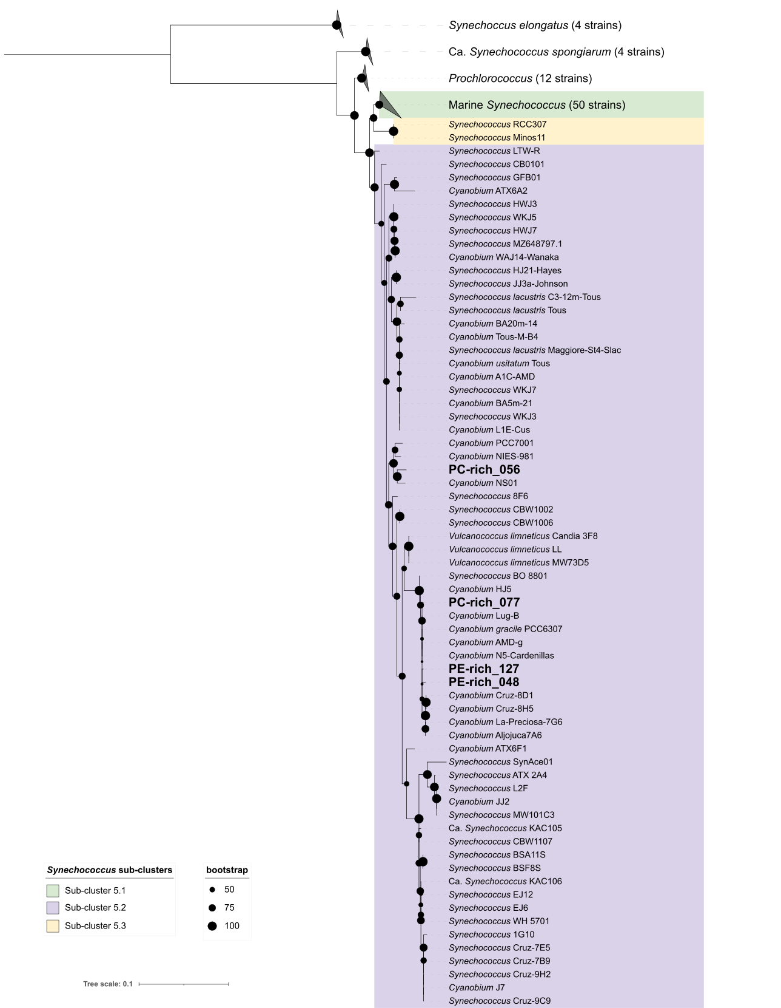

**Fig. S1.** Phylogenetic tree derived from partial 16S rRNA gene sequences using topology given by Maximum Likelihood (1000 bootstraps). Support values are indicated by the size of internal nodes. Strains used in this study are shown in bold. Phylogenetic trees were created using IQ-TREE v. 1.6.12 (Hoang et al. 2018), using GTR+F+I+I+R3 model determined by ModelFinder (Kalyaanamoorthy et al. 2017). Bootstrap values were calculated with 1000 replicates (Hoang et al. 2018). Samples for total genomic DNA were collected by harvesting 10 mL of each culture and centrifuging for 8 minutes at 8,000 x g. DNA was extracted using the FastDNA™ SPIN Kit for Soil (MP Biomedicals) with Matrix E columns following manufacturer instructions with the addition of an incubation with proteinase-K (1% final concentration) at 55°C for one hour. DNA concentration was measured using an Invitrogen Qubit 2.0 fluorometer (Thermo Fisher Scientific Inc.) and purity was assessed using a Thermo Scientific™ NanoDrop 2000 spectrophotometer (Thermo Fisher Scientific Inc.).

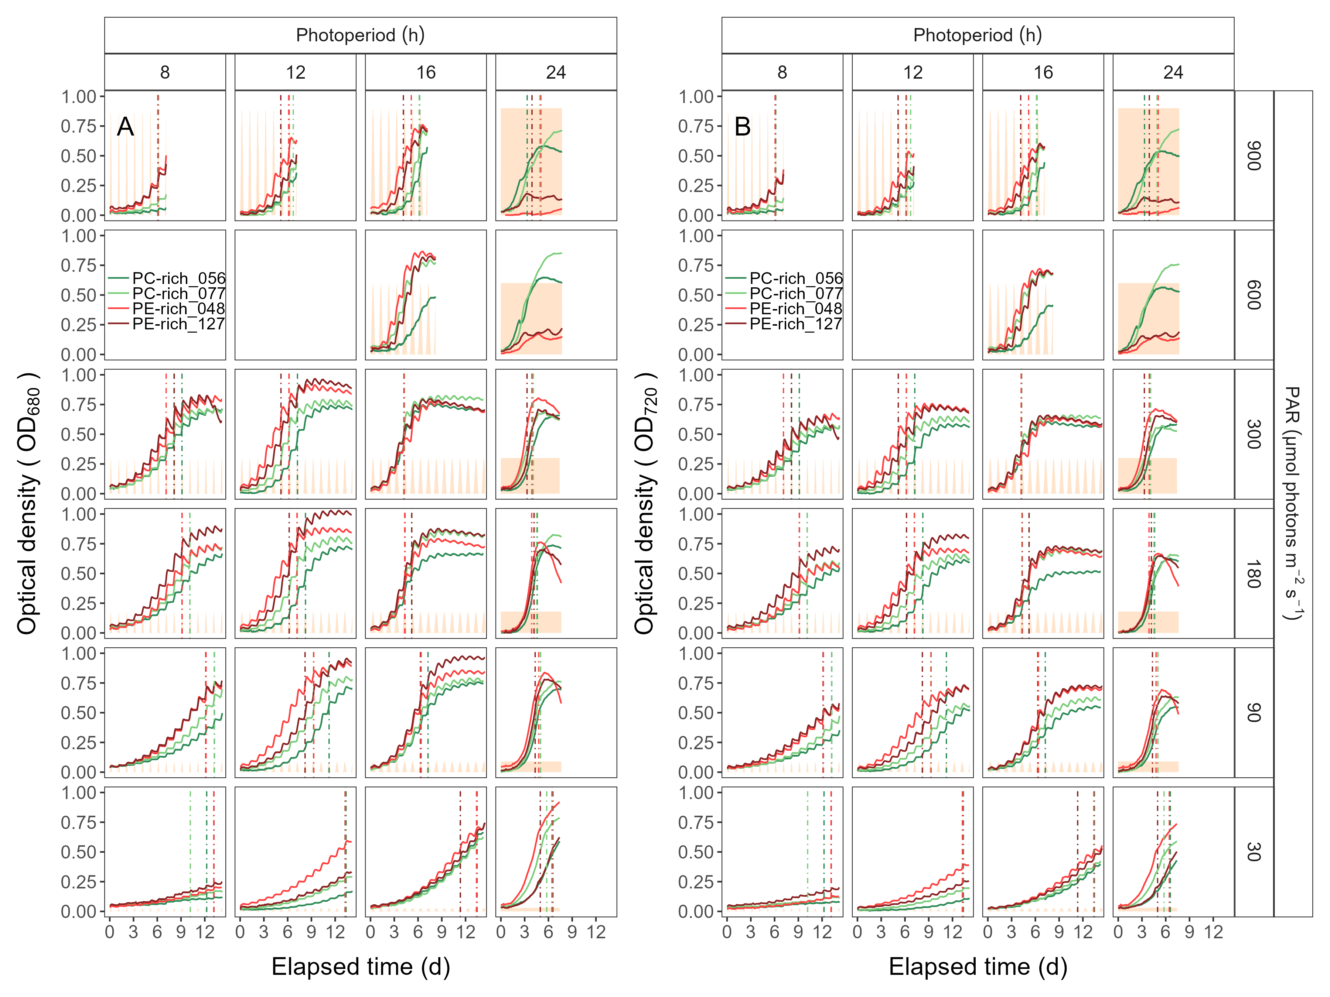

**Fig. S2.** Growth curves, tracked as OD680 (**A**) and OD720 (**B**) vs. elapsed time (d). Growth curves were estimated over 5-min intervals for two PC-rich cultures (056; dark green, 077; light green) and two PE-rich cultures (048; light red, 127; dark red) of *Synechococcus* sp. grown at 30, 90, 180, 300, 600, or 900 peak PAR µmol photons m−2s−1; and photoperiods of 8, 12, 16, or 24 h. The vertical lines represent the time when the cultures reached the maximum of the 1st derivative of OD680, or maximum absolute hourly growth (tMaxAHG), taken as an index of transition from exponential to pre-stationary growth phases. The orange area represents the photoperiods, with peak PAR x 1/1000 to scale to the Y axis.

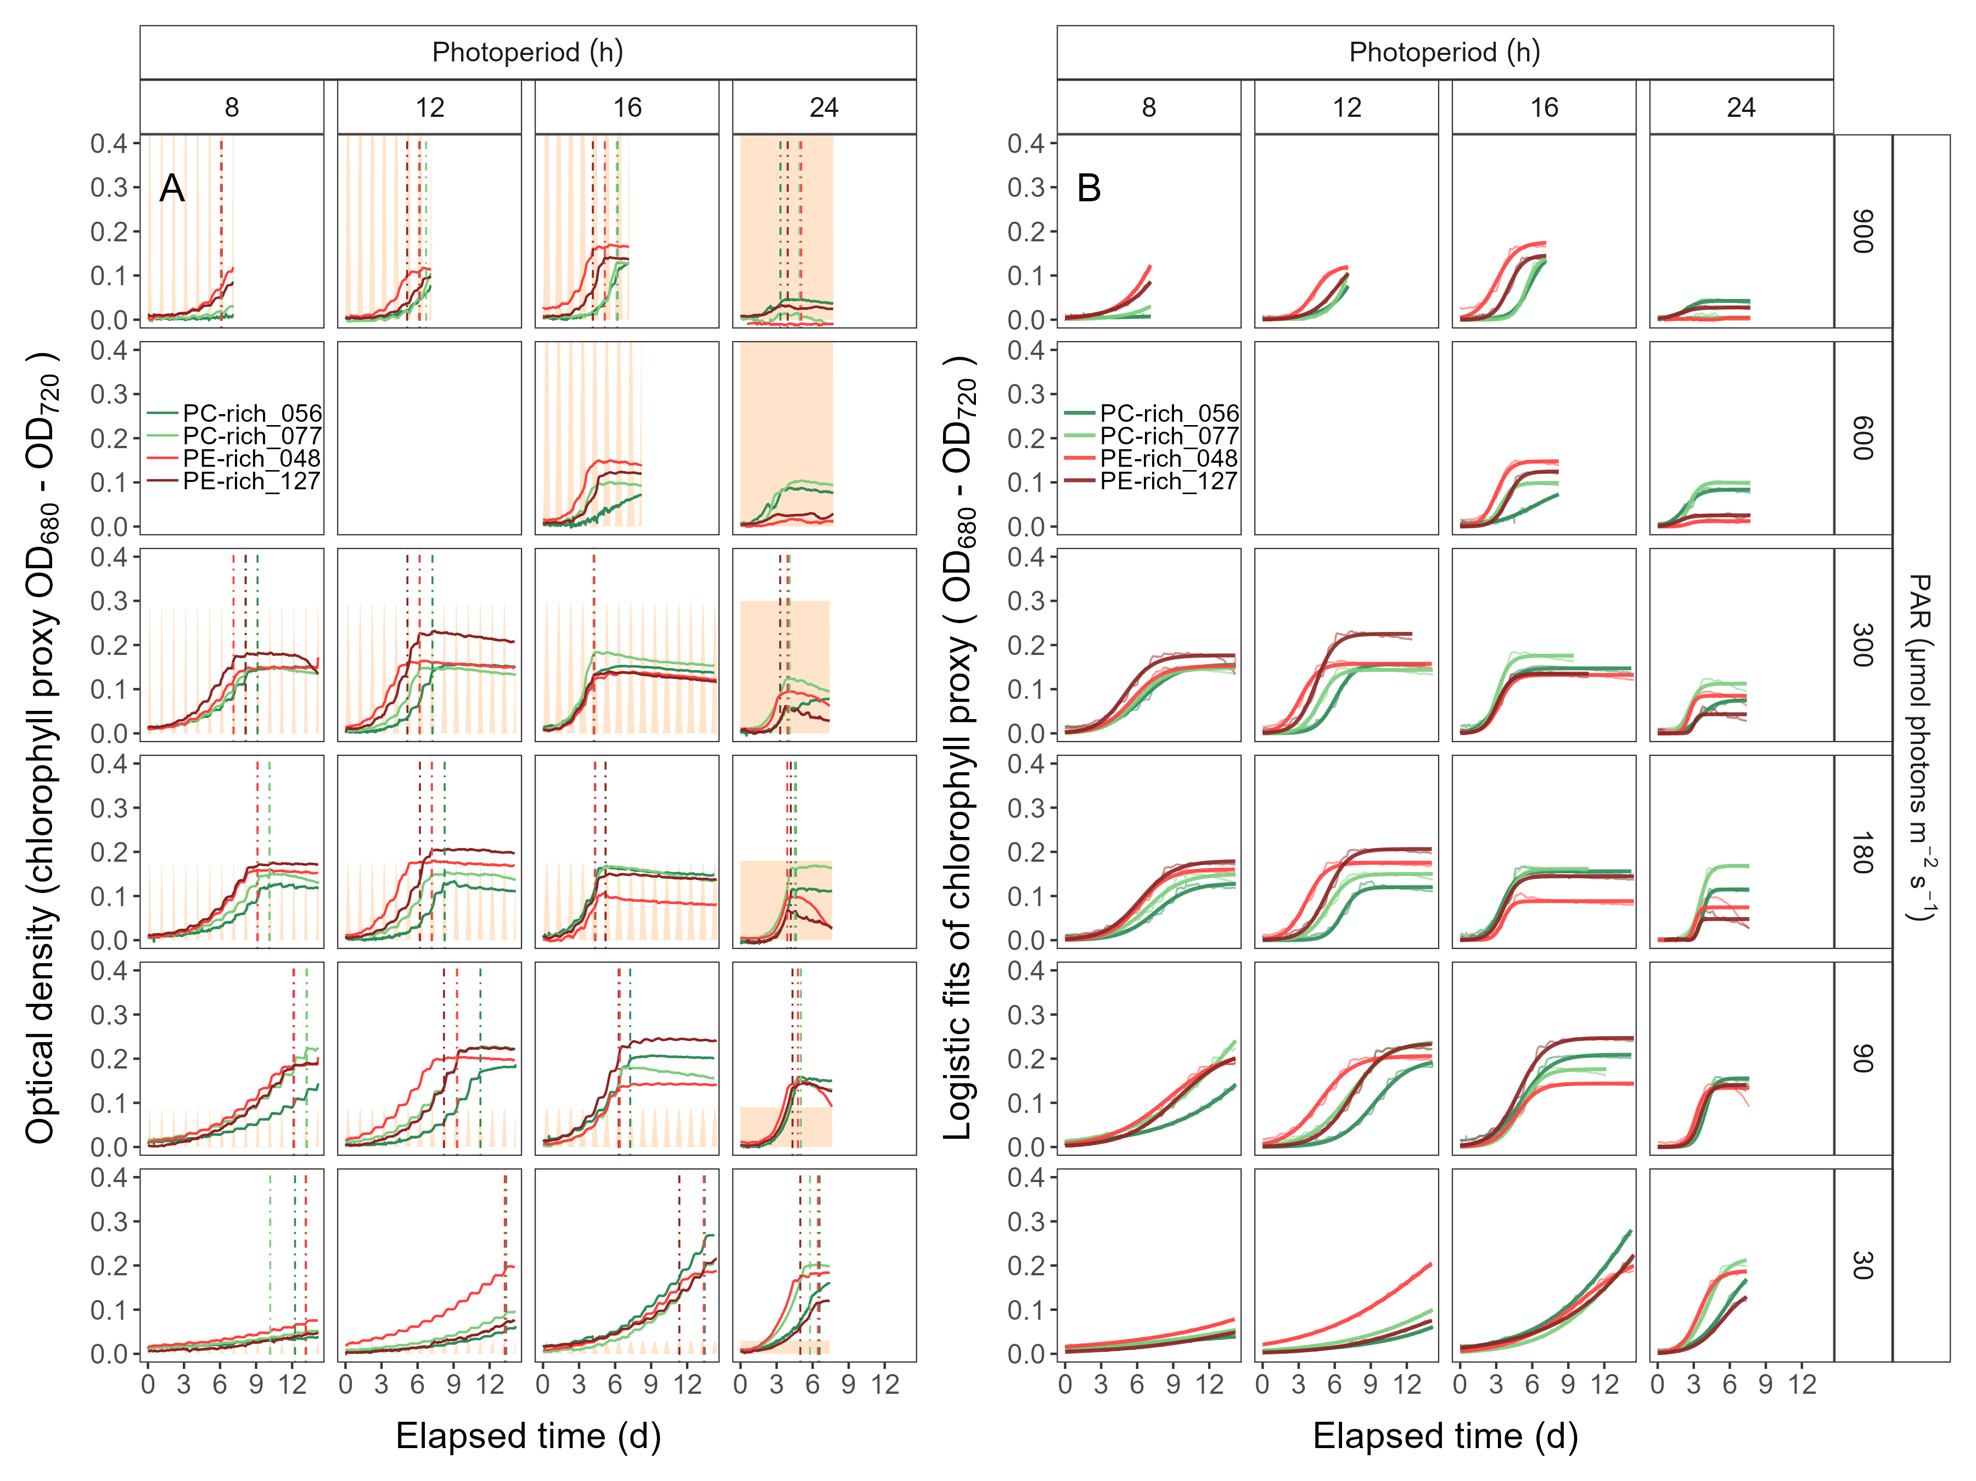

**Fig. S3.** (**A**) Growth curves (tracked as chlorophyll proxy OD680-OD720; Δ OD) vs. elapsed time (d). Growth curves were estimated over 5-min intervals for two PC-rich cultures (056; dark green, 077; light green) and two PE-rich cultures (048; light red, 127; dark red) of *Synechococcus* sp. grown at 30, 90, 180, 300, 600, or 900 peak PAR µmol photons m−2s−1; and photoperiods of 8, 12, 16, or 24 h. The vertical lines represent the time when the cultures reached the maximum of the 1st derivative of OD680, or maximum absolute hourly growth (tMaxAHG), taken as an index of transition from exponential to pre-stationary growth phases. The orange area represents the photoperiods, with peak PAR x 1/2000 to scale to the Y axis. (**B**) Logistic fits (thick lines) of chlorophyll proxy OD680-OD720 (Δ OD) vs. elapsed time (d). Growth curves (thin line) measured over 5-min intervals for each strain were also presented.

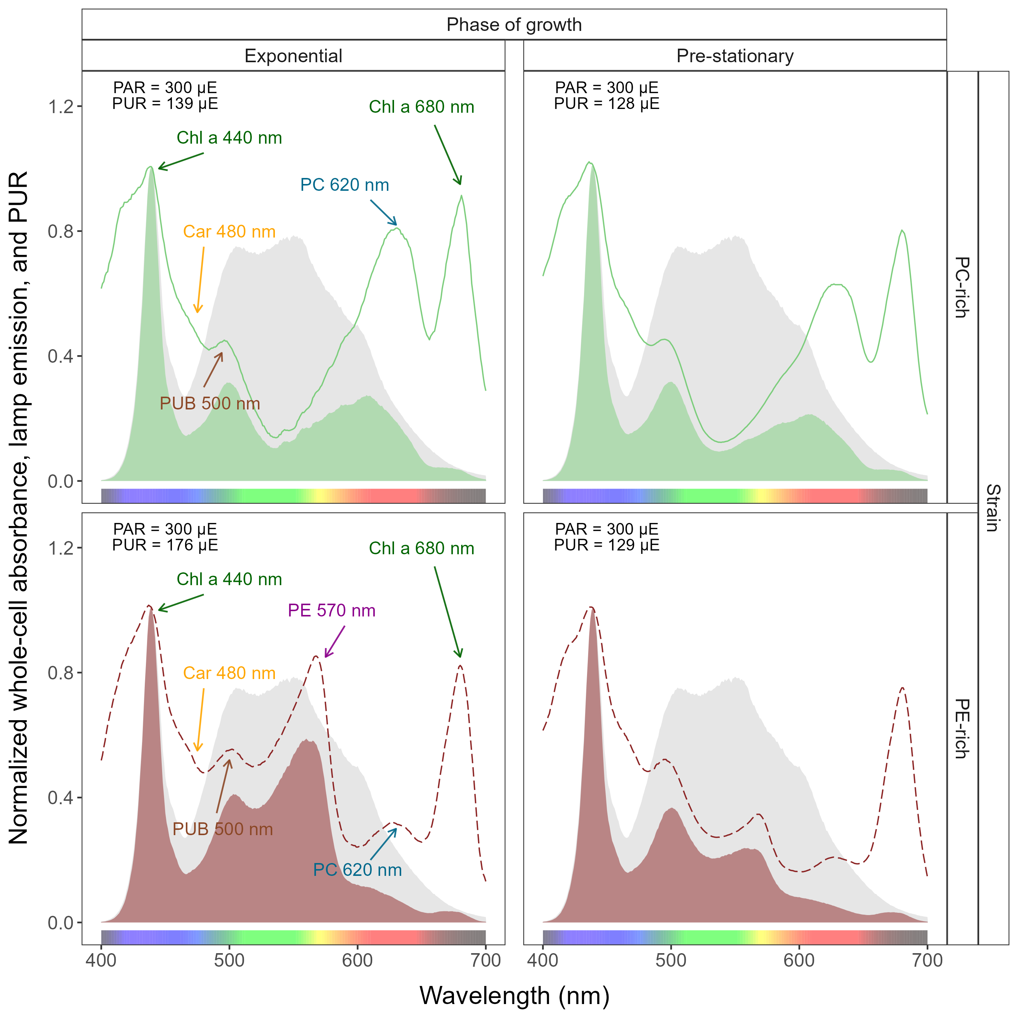

**Fig. S4.** Whole-cell absorbance spectra of PC-rich (077; solid light green lines) or PE-rich (127; dashed dark red lines) cultures of *Synechococcus* sp. Representative absorbance spectra, normalized to 440 nm (NormA440), were measured from the exponential or pre-stationary phases of growth, together with emission spectra of the white LED lamp used for PAR, normalized to emission at 440 nm (NormEm440, light gray area), in this example PAR was 300 µmol photons m−2s−1. Estimated Photosynthetically Usable Radiation (PUR) is shown as a darker green area for the PC-rich strain and a darker red area for the PE-rich strain, with PUR given for each culture (µE = µmol photons m−2s−1). Peaks characteristic of known pigments are labeled; Chl *a*, chlorophyll *a*; PC, phycocyanin; PE, phycoerythrin; PUB, phycourobilin; Car, carotenoids.



**Fig. S5.** Single turnover (ST) fluorescence induction by Fast Repetition Rate fluorometry (FRRf). (**A**) Examples of fluorescence yield vs. elapsed time (µs) for PE-rich culture of *Synechococcus* sp. (048) in the dark (dark-relaxed; 0 µmol photons m−2s−1) and under actinic PAR (in this example 80 µmol photons m−2s−1) using blue LED (Ex445nm; open blue circles) or orange (Ex590nm; open orange diamonds) excitation. The ST technique delivers a series of flashlets for non-intrusive, repeated monitoring of chlorophyll fluorescence parameters (including *F*O, *F*′, *F*M, *F*M′, τ1-τ3, τ1′-τ3′, σPSII, and σPSII′). (**B**) Linear regressions of uncalibrated PSII electron flux (*JV*PSII) vs. e− L−1 s−1 derived from simultaneously measured oxygen evolution Light Response Curves (LRC) under blue LED (Ex445nm; open blue circles) or orange (Ex590nm; open orange diamonds) excitation. (**C**) Rapid Light Curve (RLC), fit with a three parameter model (Harrison and Platt 1986), for PSII electron flux (*JV*PSII; µmol e− µmol Chl *a*−1 s−1) vs. actinic PAR measured under blue LED (Ex445nm; open blue circles) or orange (Ex590nm; open orange diamonds) excitation.

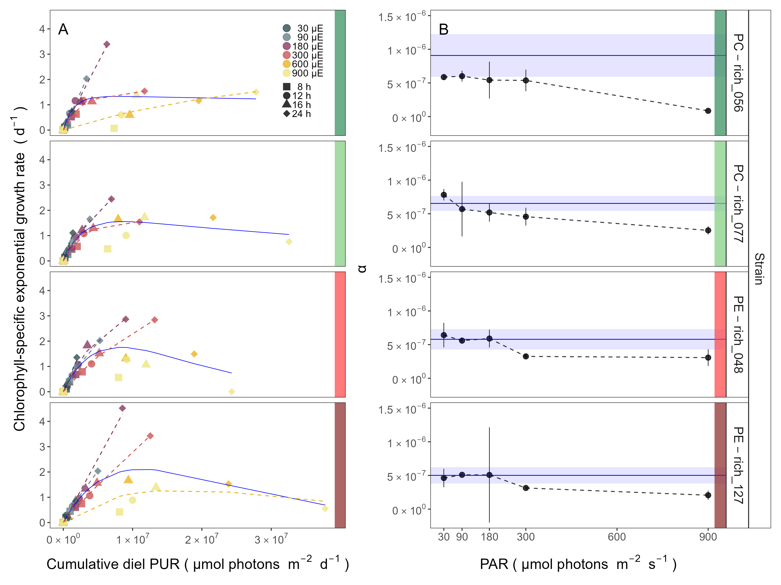

**Fig. S6.** (**A**) Chlorophyll-specific exponential growth rates (d−1) vs. cumulative diel Photosynthetically Usable Radiation (PUR, µmol photons m−2d−1). Growth rates (± SE falling within symbols) were estimated from logistic fits of chlorophyll proxy OD680 – OD720 (ΔOD) vs. elapsed time (Fig. 1, Fig. S3B), for two PC-rich cultures (056; dark green, 077; light green) and two PE-rich cultures (048; light red, 127; dark red) of *Synechococcus* sp. grown at 30 (dark gray), 90 (light gray), 180 (purple), 300 (red), 600 (orange), or 900 (yellow) peak PAR µmol photons m−2s−1 (µE); and photoperiods of 8 (square), 12 (circle), 16 (triangle), or 24 (diamond) h. Solid blue line shows a fit of the pooled growth rates through peak PAR for each strain, with a three parameter model (Harrison and Platt, 1986). We also fit the same model separately for 30 (dark gray), 90 (light gray), 180 (purple), 300 (red), 600 together with 900 (orange) peak PAR µmol photons m−2s−1, only when they were each significantly different (ANOVA, *p* < 0.05) from the fit of pooled data. (**B**) Alpha parameters of the initial rise of growth rate (α) vs. cumulative diel Photosynthetically Usable Radiation (PUR), estimated from data pooled for each peak PAR (points (± SE) connected by dashed lines), and estimated for all data across all peak PAR, for each strain (solid blue horizontal line ± SE).

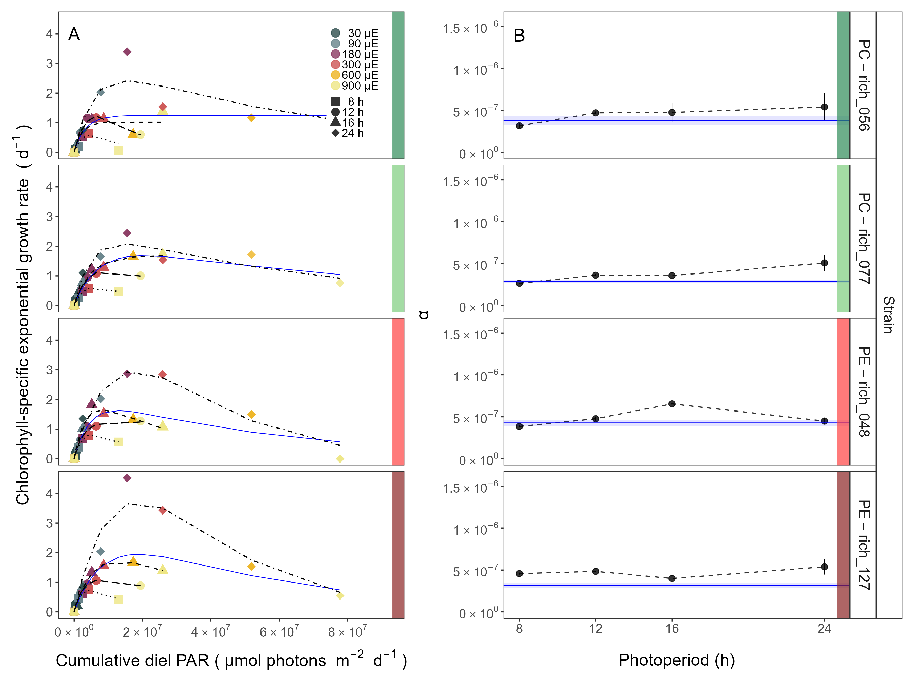

**Fig. S7.** (**A**) Chlorophyll-specific exponential growth rates (d−1) vs. cumulative diel PAR (µmol photons m−2d−1). Growth rates (± SE falling within symbols) were estimated from logistic fits of chlorophyll proxy OD680 – OD720 (ΔOD) vs. elapsed time (Fig. 1, Fig. S3B), for two PC-rich cultures (056; dark green, 077; light green) and two PE-rich cultures (048; light red, 127; dark red) of *Synechococcus* sp. grown at 30 (dark gray), 90 (light gray), 180 (purple), 300 (red), 600 (orange), or 900 (yellow) peak PAR µmol photons m−2s−1 (µE); and photoperiods of 8 (square), 12 (circle), 16 (triangle), or 24 (diamond) h. Solid blue line shows a fit of the pooled growth rates through photoperiod (h) for each strain, with a three parameter model (Harrison and Platt 1986). We also fit the same model separately for 8 (dotted line), 12 (long dash line), 16 (dashed line), or 24 (two dash line) h photoperiods, since for all strains they were each significantly different (ANOVA, *p* < 0.05) from the fit of pooled data. (**B**) Alpha parameters of the initial rise of growth rate (α) vs. cumulative diel PAR, estimated from data pooled for each photoperiod (points (± SE) connected by dashed lines), and estimated for all data across photoperiods (solid blue horizontal line ± SE), for each strain.

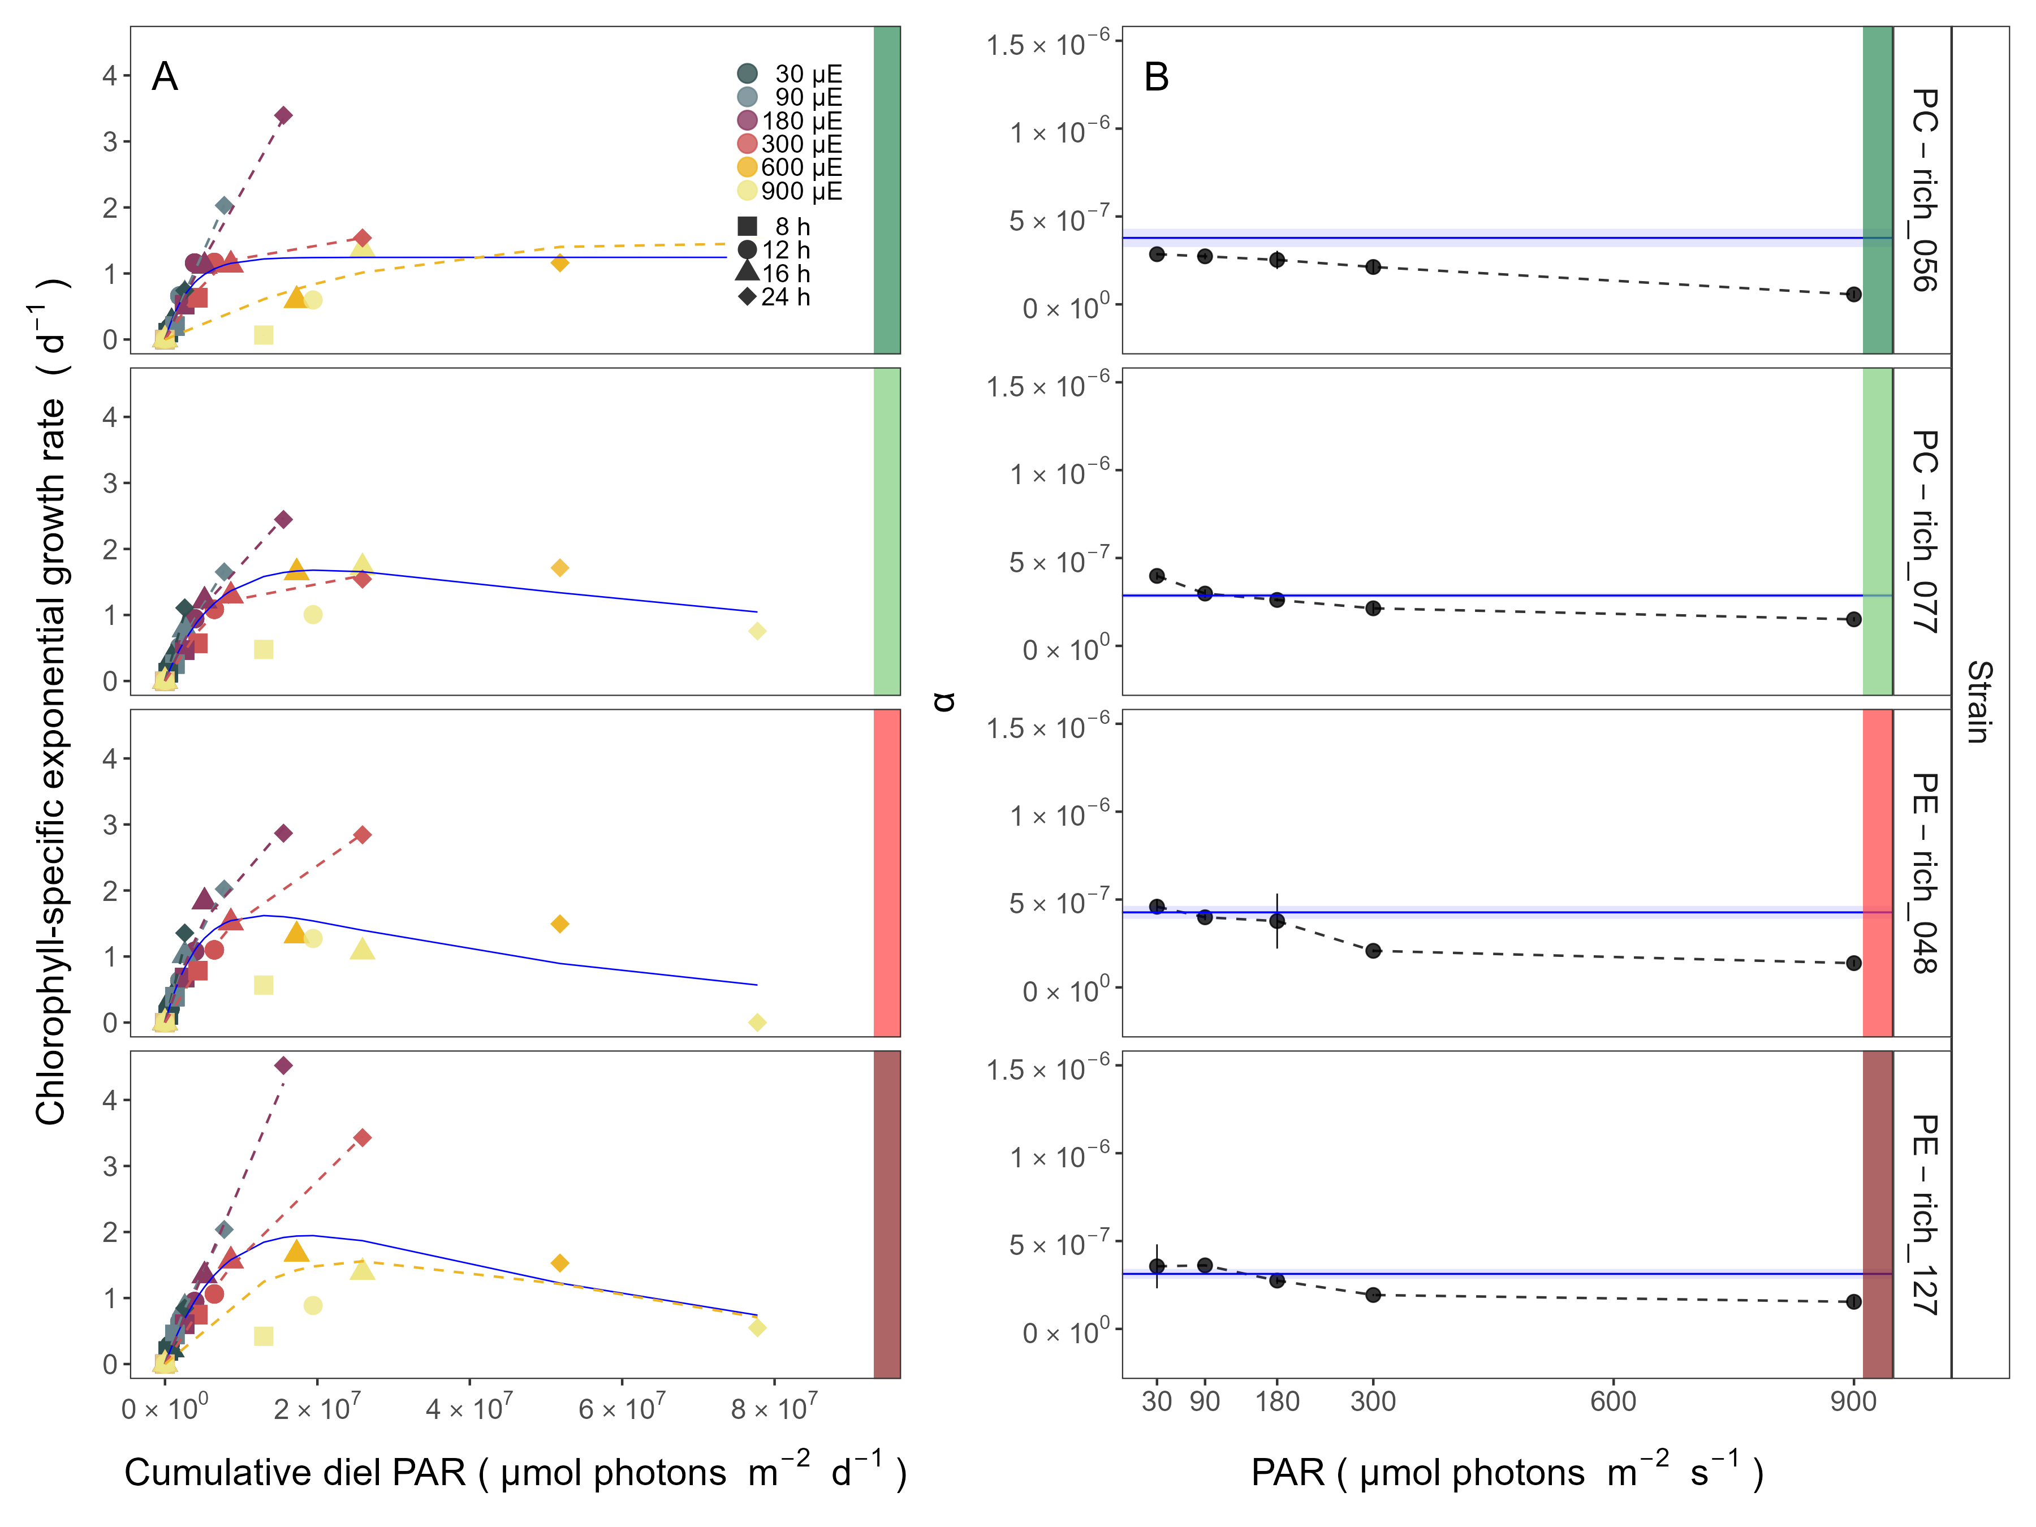

**Fig. S8.** (**A**) Chlorophyll-specific exponential growth rates (d−1) vs. cumulative diel PAR (µmol photons m−2d−1). Growth rates (± SE falling within symbols) were estimated from logistic fits of chlorophyll proxy OD680 – OD720 (ΔOD) vs. elapsed time (Fig. 1, Fig. S3B), for two PC-rich cultures (056; dark green, 077; light green) and two PE-rich cultures (048; light red, 127; dark red) of *Synechococcus* sp. grown at 30 (dark gray), 90 (light gray), 180 (purple), 300 (red), 600 (orange), or 900 (yellow) peak PAR µmol photons m−2s−1 (µE); and photoperiods of 8 (square), 12 (circle), 16 (triangle), or 24 (diamond) h. Solid blue line shows a fit of the pooled growth rates through peak PAR for each strain, with a three parameter model (Harrison and Platt, 1986). We also fit the same model separately for 30 (dark gray), 90 (light gray), 180 (purple), 300 (red), 600 together with 900 (orange) peak PAR µmol photons m−2s−1, only when they were each significantly different (ANOVA, *p* < 0.05) from the fit of pooled data. (**B**) Alpha parameters of the initial rise of growth rate (α) vs. cumulative diel PAR, estimated from data pooled for each peak PAR (points (± SE) connected by dashed lines), and estimated for all data across all peak PAR, for each strain (solid blue horizontal line ± SE).

## PUR/PAR ratio vs. cumulative diel PAR

The PUR/PAR ratio is an index of the efficacy of light capture for a culture under a given growth condition; showing the fraction of PAR that can be captured by the absorbance of the cells (Fig. S9). For the two PC-rich and, particularly, for the two PE-rich cultures of *Synechococcus* PUR/PAR decayed exponentially to a plateau, with increasing cumulative diel PAR, when pooling PUR/PAR data across different combinations of photoperiod and peak PAR. Although all strains followed a similar trend, the single phase exponential decay model fit parameters varied significantly among strains, during their exponential phase of growth (Table S9), except the model fits from PE-rich_048 and PE-rich_127, where no data was received. Moreover, the PUR/PAR ratio was higher in the PE-rich strains under low cumulative diel photon dose during their exponential phase of growth (y0 greater or equal to 0.9), but decayed towards a plateau close to the PC-rich strains as cumulative diel photon dose increases (yf = 0.5). On the other hand, the single phase exponential decay model fits did not differ significantly among strains, during their pre-stationary phase of growth (Table S9). During this phase, response of PUR/PAR ratio to increasing cumulative diel PAR exhibits damping, maintaining a consistent trend across all strains within the yf range of 0.4 to 0.5, with the exception of the PE-rich_048 strain. We also find that model fits from different phases of growth differed within a given strain, with the exception of PC-rich_056 (Table S9). A similar decay trend was observed for Phycobiliprotein to Chl *a* ratio (µg:µg) across cumulative diel PAR (Fig. S10).

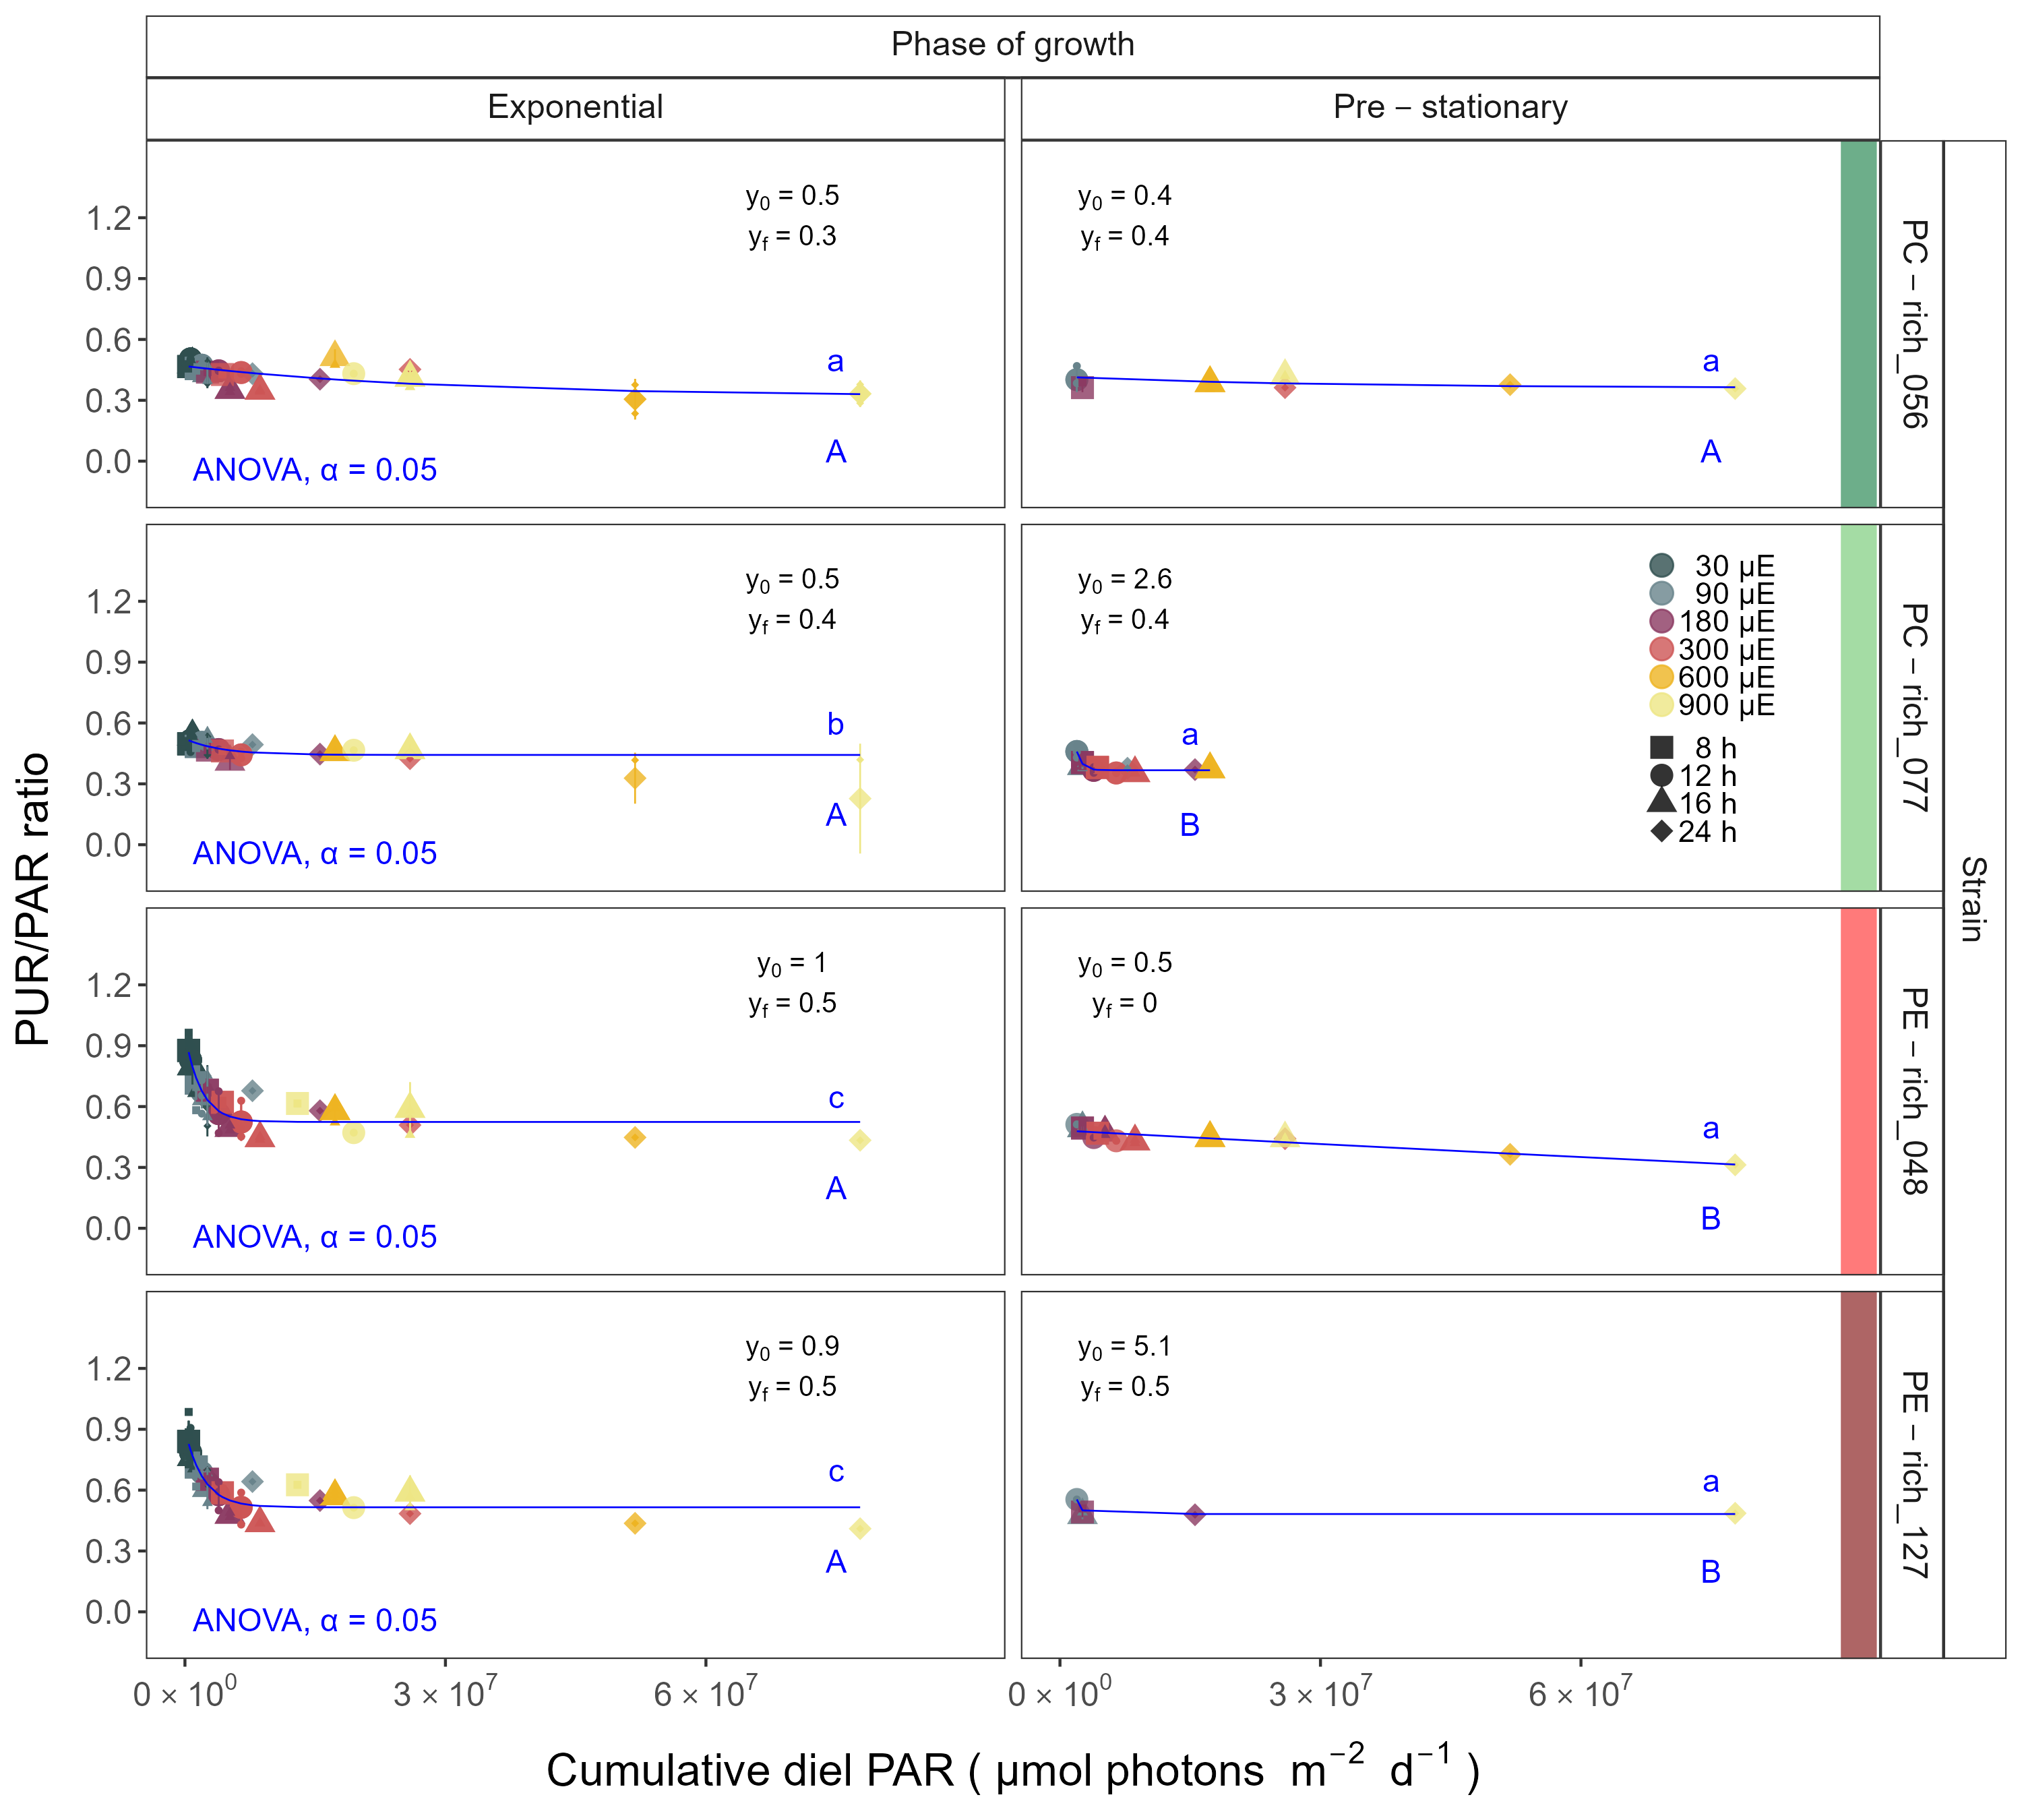

**Fig. S9.** Changes in PUR/PAR ratio vs. cumulative diel PAR (µmol photons m−2d−1). PUR/PAR ratio was estimated for two PC-rich cultures (056; dark green, 077; light green) and two PE-rich cultures (048; light red, 127; dark red) of *Synechococcus* sp. grown at 30 (dark gray), 90 (light gray), 180 (purple), 300 (red), 600 (orange), or 900 (yellow) peak PAR µmol photons m−2s−1 (µE); and photoperiods of 8 (square), 12 (circle), 16 (triangle), or 24 (diamond) h. Figure presents data (smaller symbols) and means (bigger symbols) from exponential or pre-stationary phase of growth. Blue solid line shows single phase exponential decay fit for data from each strain and growth phase, with fit parameters presented. Different lowercase letters indicate statistically significant differences between the fit models for different strains within a given phase of growth. Different uppercase letters indicate statistically significant differences between the fit models for different phases of growth within a given strain (ANOVA; *p* < 0.05).

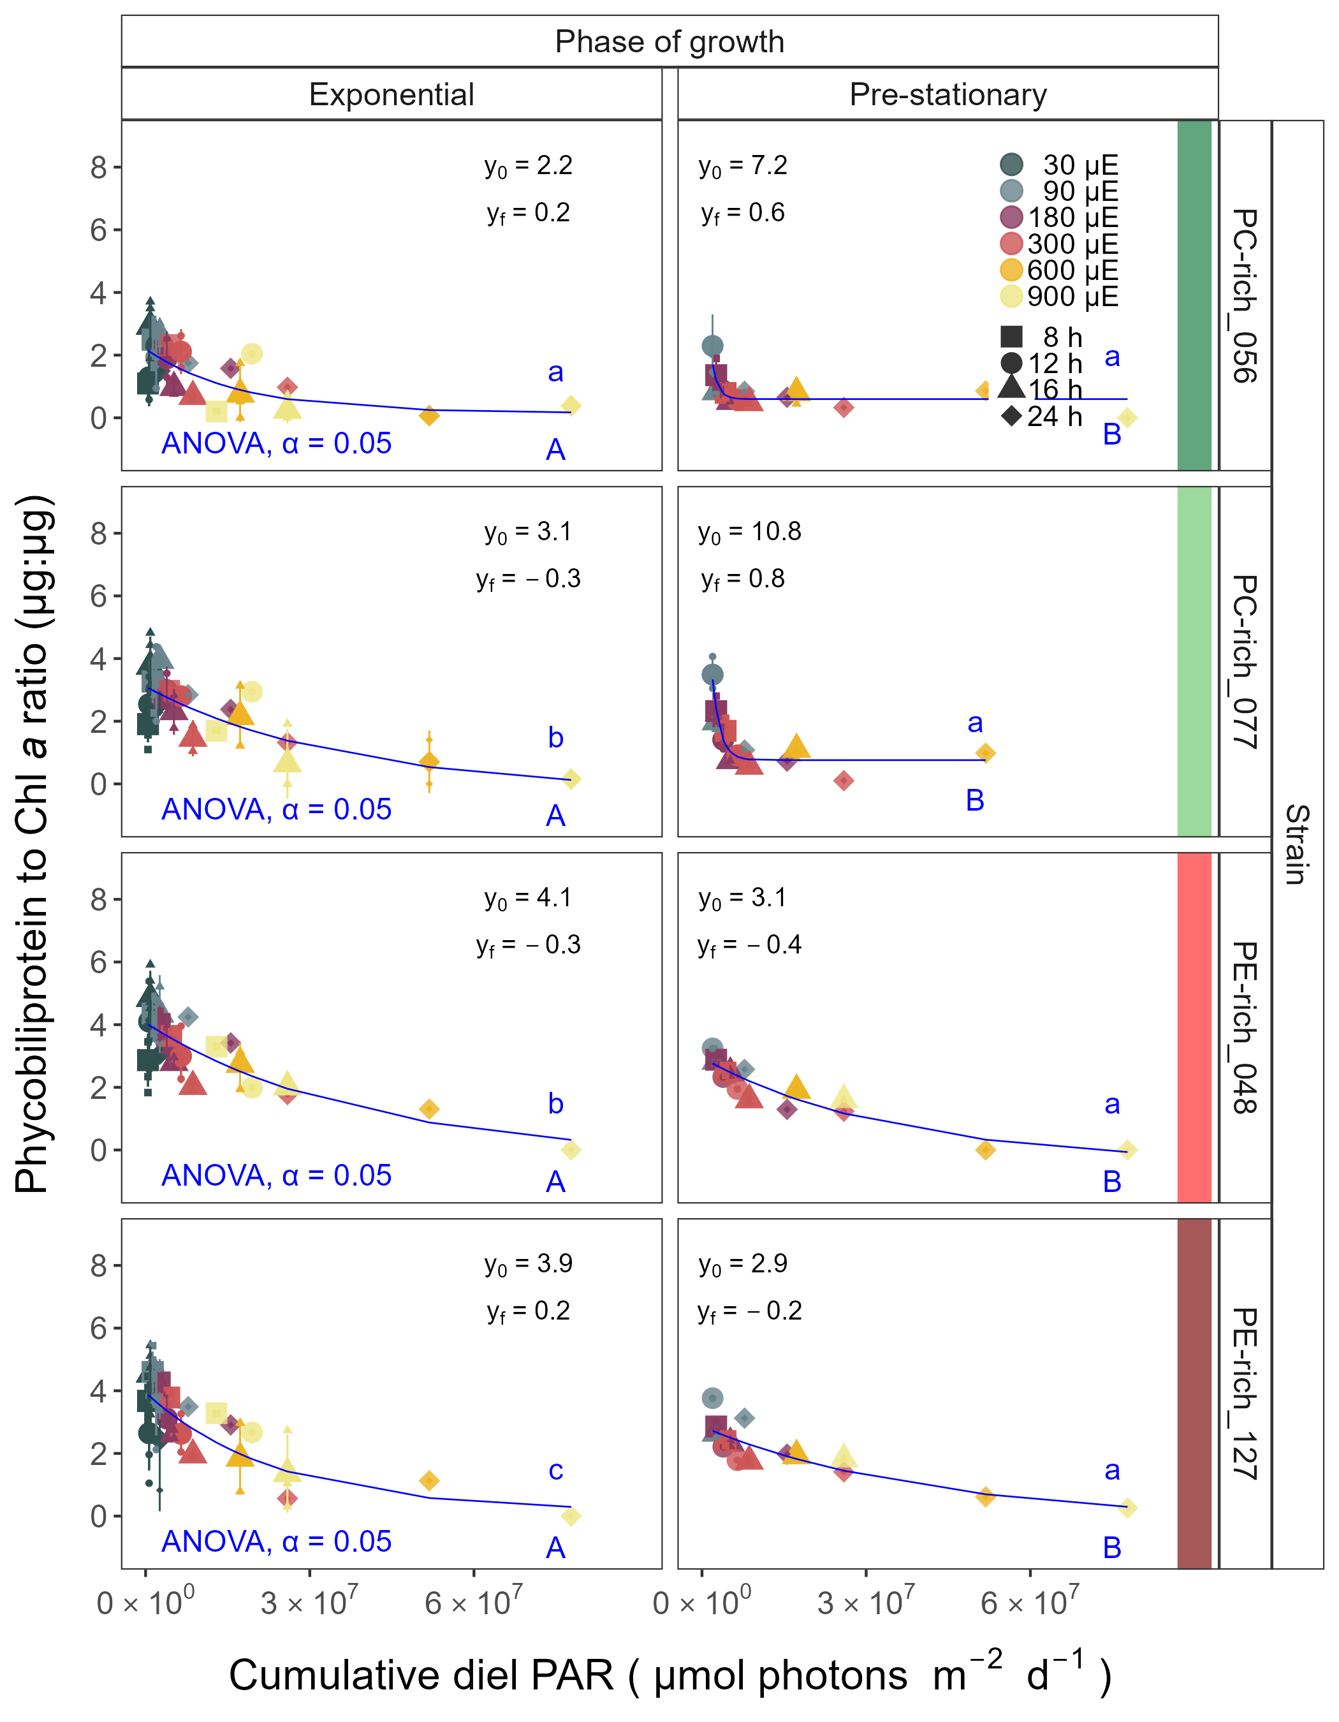

**Fig. S10.** Changes of Phycobiliprotein to Chl *a* ratio (µg:µg) vs. cumulative diel PAR (µmol photons m−2d−1). Phycobiliprotein to Chl *a* ratio was estimated for two PC-rich cultures (056; dark green, 077; light green) and two PE-rich cultures (048; light red, 127; dark red) of *Synechococcus* sp. grown at 30 (dark gray), 90 (light gray), 180 (purple), 300 (red), 600 (orange), or 900 (yellow) peak PAR µmol photons m−2s−1 (µE); and photoperiods of 8 (square), 12 (circle), 16 (triangle), or 24 (diamond) h. Figure presents data (smaller symbols) and means (bigger symbols) from exponential or pre-stationary phase of growth. Blue solid line shows single phase exponential decay fit for data from each strain and growth phase, fit parameters are presented. Different lowercase letters indicate statistically significant differences between the fit models for different strains within a given phase of growth. Different uppercase letters indicate statistically significant differences between the fit models for different phases of growth within a given strain (ANOVA; *p* < 0.05).

## Effective absorption cross section of PSII of picocyanobacteria

The effective absorption cross section of PSII (σPSIIʹ, nm2 quanta−1), was estimated using FRRf induction curves using Ex590nm (orange) excitation, for two PC-rich (056, 077) and two PE-rich (048, 127) cultures of *Synechococcus* grown at 30, 90, 180, 300, 600, or 900 peak PAR µmol photons m−2s−1 (µE); and photoperiods of 8, 12, 16, or 24 h (Fig. S11). The σPSIIʹ measured under diel peak PAR growth light under Ex445nm (blue) excitation vs. cumulative diel photon dose is shown in Fig. S12, Table S12.

All strains showed consistent patterns of sharp, exponential decay of effective absorption cross section for PSII photochemistry vs. cumulative diel photon doses, across different combinations of photoperiod and peak PAR (Fig. S11 A). Although all strains showed this response pattern, the exponential decay fits differed significantly among two PC-rich strains and PE-rich_048 strains during their exponential phase of growth (Table S11). PE-rich strains showed higher σPSIIʹ under low cumulative diel photon dose (y0 about 0.8 and yf about 4) than did PC-rich strains. During pre-stationary phase this response dampens in the PC-rich strains but persists in the PE-rich strains (Table S11). σPSIIʹ for the PE-rich strains during pre-stationary phase of growth still remain higher (yf between 2.3 – 3.0) than in the PC-rich strains (yf between 1.4 – 1.7) even as cumulative diel photon dose increases. Model fits from different phases of growth differed within a given strain, with the exception of PE-rich_048 (Table S11).

Effective absorption cross section of PSII (σPSIIʹ; nm2 quanta−1), measured under diel peak PAR growth light with Ex590nm (orange) excitation through phycobilisome absorbance PAR (Fig. S11 B) shows positive linear correlations with the Phycobiliprotein to Chl *a* ratio, although strains in exponential growth show significant scatter around this positive relation, likely related to regulatory control of σPSIIʹ under different measurement PAR, beyond pigment composition. Under pre-stationary phase the relationship between σPSIIʹ and Phycobiliprotein to Chl *a* ratio was more consistent, suggesting increased reliance upon compositional regulation to control light delivery to PSII, as opposed to shorter-term physiological regulation under changing light. The linear fits of σPSIIʹ vs. Phycobiliprotein to Chl *a* ratio also vary significantly between PC-rich_077 and two PE-rich strains during their exponential phase of growth. During pre-stationary phase we noted significant differences between two PC-rich strains and PE-rich_048. Moreover, significant differences between the fit models for varying phases of growth were noted for PC-rich strains 056 and 077 (*t*-test; *p* < 0.05, Table S14).

Changes in effective absorption cross section of PSII (σPSII; nm2 quanta−1) measured in the dark with Ex590nm (orange) excitation vs. Phycobiliprotein to Chl *a* ratio (Fig. S13 A, Table S15) and σPSIIʹ measured under diel peak PAR growth light under Ex445nm (blue) excitation vs. Phycobiliprotein to Chl *a* ratio (Fig. S13 B and Table S13) are also shown.



**Fig. S11.** (**A**) Effective absorption cross section of PSII (σPSIIʹ; nm2 quanta−1) measured under diel peak PAR growth light vs. cumulative diel PAR (µmol photons m−2d−1); blue solid line shows single phase exponential decay fit for data from each strain and growth phase. (**B**) Changes of σPSIIʹ measured under diel peak PAR growth light vs. the ratio of sum of µg phycobilins (PE, PC, APC protein, Phycobiliprotein) to µg Chl *a*; blue solid line shows linear model fit for data from each strain and growth phase. σPSIIʹ was estimated using FRRf induction curves with excitation of phycobilisomes (Ex590nm, orange), for two PC-rich cultures (056; dark green, 077; light green) and two PE-rich cultures (048; light red, 127; dark red) of *Synechococcus* sp. grown at 30 (dark gray), 90 (light gray), 180 (purple), 300 (red), 600 (orange), or 900 (yellow) peak PAR µmol photons m−2s−1 (µE); and photoperiods of 8 (square), 12 (circle), 16 (triangle), or 24 (diamond) h. Figure presents data (smaller symbols) and means (bigger symbols) from exponential or pre-stationary phase of growth. Different lowercase letters indicate statistically significant differences between the fit models for different strains within a given phase of growth. Different uppercase letters indicate statistically significant differences between the fit models for different phases of growth within a given strain (*p* < 0.05).

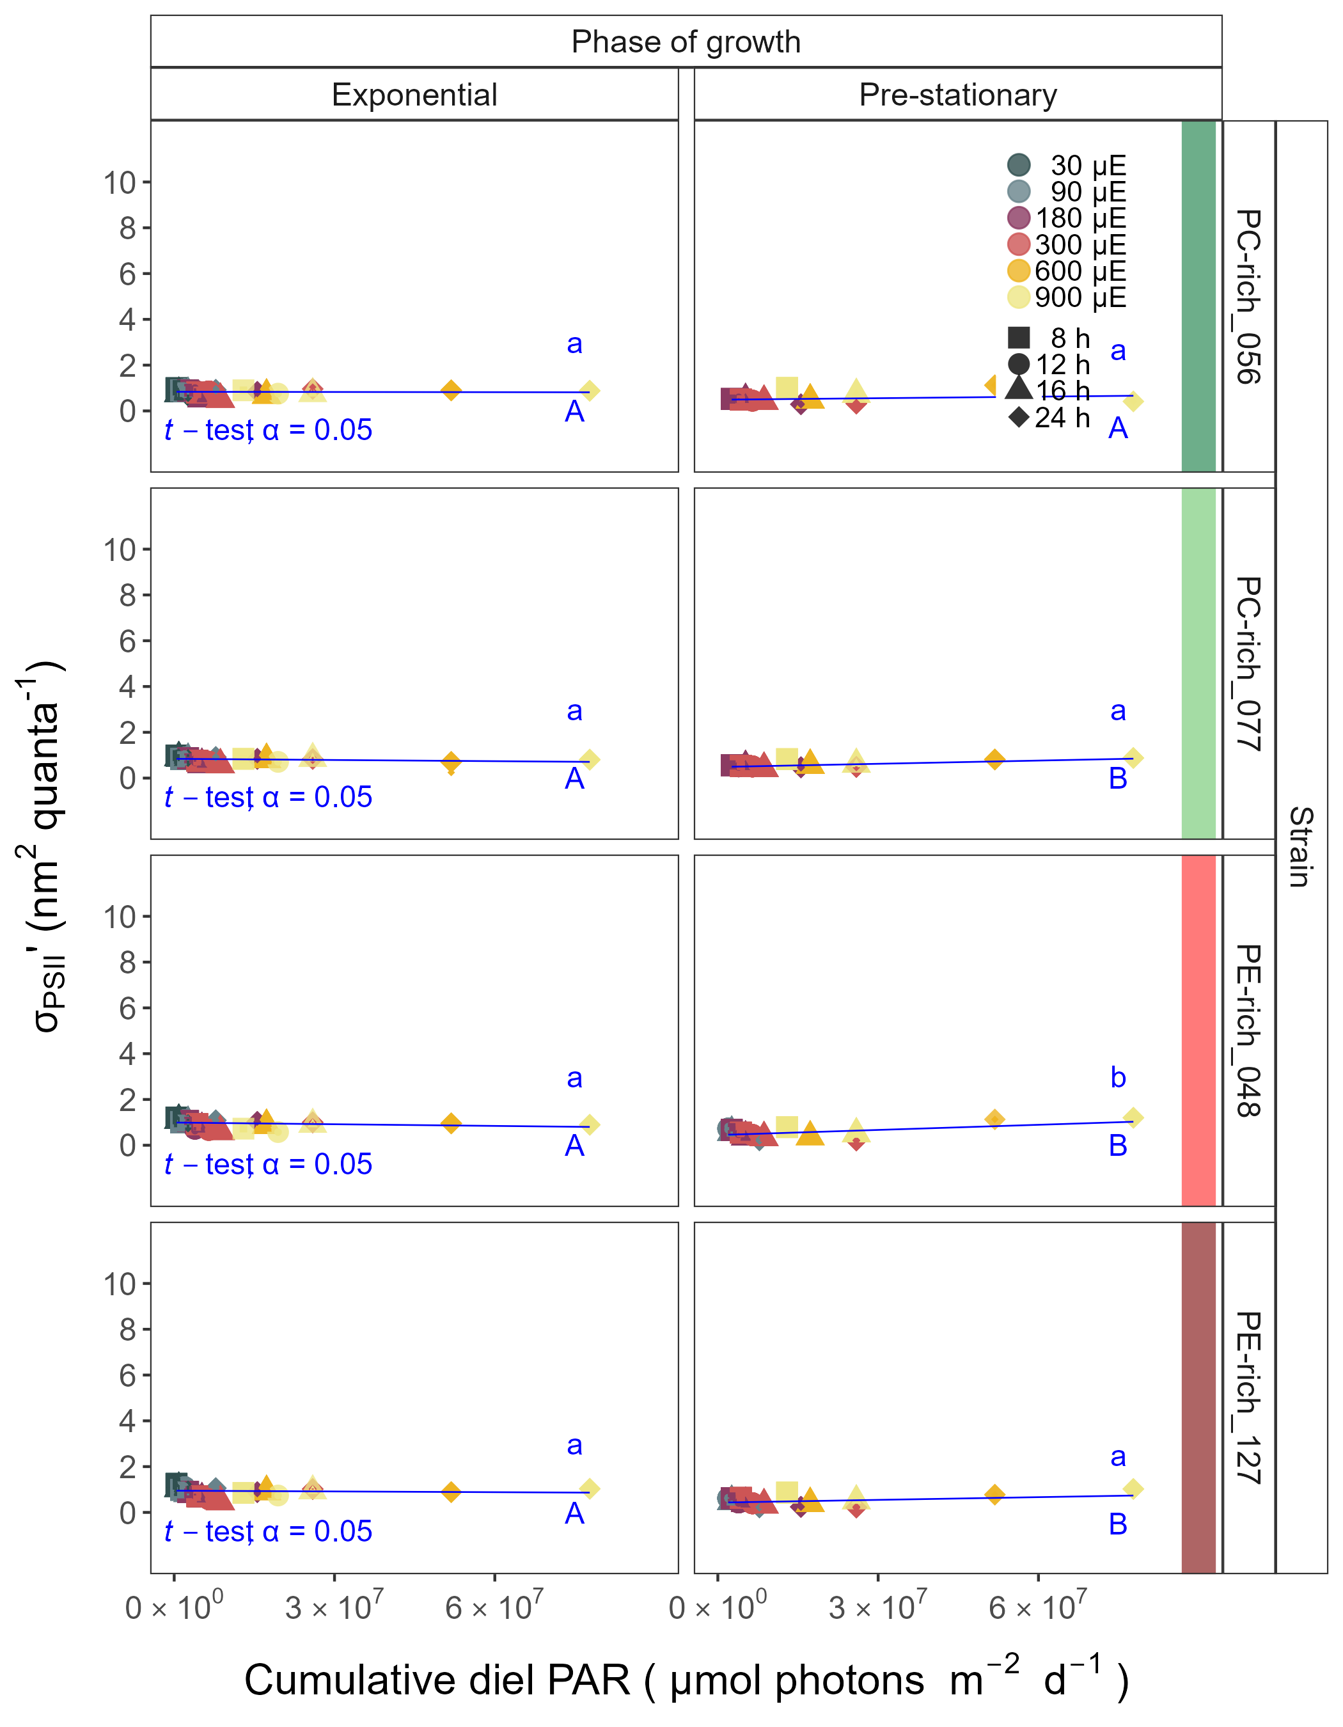

**Fig. S12.** Effective absorption cross section of PSII (σPSII′; nm2 quanta−1) measured under diel peak PAR growth light under blue (Ex445nm) excitation vs. cumulative diel PAR (µmol photons m−2d−1). σPSII′ was estimated for two PC-rich cultures (056; dark green, 077; light green) and two PE-rich cultures (048; light red, 127; dark red) of *Synechococcus* sp. grown at 30 (dark gray), 90 (light gray), 180 (purple), 300 (red), 600 (orange), or 900 (yellow) peak PAR µmol photons m−2s−1 (µE); and photoperiods of 8 (square), 12 (circle), 16 (triangle), or 24 (diamond) h. Figure presents data (smaller symbols) and means (bigger symbols) from exponential or pre-stationary phase of growth. Blue solid line shows linear model fit for data from each strain and growth phase. Different lowercase letters indicate statistically significant differences between the fit models for different strains within a given phase of growth. Different uppercase letters indicate statistically significant differences between the fit models for different phases of growth within a given strain (*t*-test; *p* < 0.05).

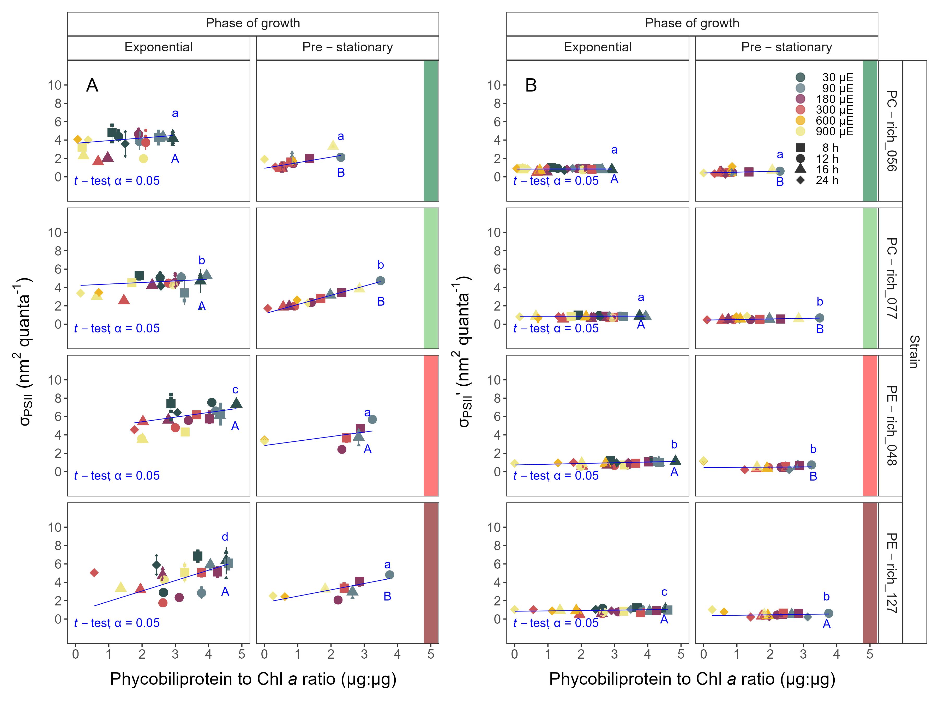

**Fig. S13.** (**A**) Changes of effective absorption cross section of PSII (σPSII; nm2 quanta−1) measured at the dark period under orange (Ex590nm) excitation vs. the ratio of sum of µg phycobilins (PE, PC, APC protein, Phycobiliprotein) to µg Chl *a*. (**B**) Changes of effective absorption cross section of PSII (σPSII′; nm2 quanta−1) measured under diel peak PAR growth light under blue (Ex445nm) excitation vs. the ratio of sum of µg phycobilins (PE, PC, APC protein, Phycobiliprotein) to µg Chl *a*. σPSII′ was estimated for two PC-rich cultures (056; dark green, 077; light green) and two PE-rich cultures (048; light red, 127; dark red) of *Synechococcus* sp. grown at 30 (dark gray), 90 (light gray), 180 (purple), 300 (red), 600 (orange), or 900 (yellow) peak PAR µmol photons m−2s−1 (µE); and photoperiods of 8 (square), 12 (circle), 16 (triangle), or 24 (diamond) h. Figure presents data (smaller symbols) and means (bigger symbols) from exponential or pre-stationary phase of growth. Blue solid line shows linear model fit for data from each strain and growth phase. Different lowercase letters indicate statistically significant differences between the fit models for different strains within a given phase of growth. Different uppercase letters indicate statistically significant differences between the fit models for different phases of growth within a given strain (*t*-test; *p* < 0.05).

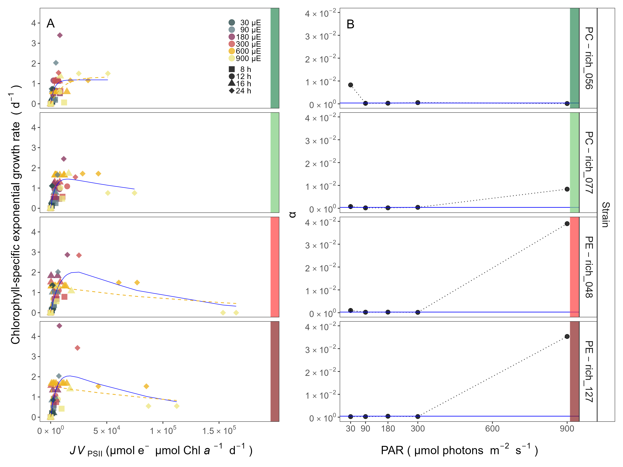

**Fig. S14.** (**A**) Chlorophyll specific exponential growth rates (d−1) vs. cumulative diel PSII electron flux (*JV*PSII; µmol e− µmol Chl *a*−1 d−1) measured under diel peak PAR growth light. Growth rates (± SE falling within symbols) were estimated from logistic fits of chlorophyll proxy OD680 – OD720 (ΔOD) vs. elapsed time (Fig. S3). PSII flux was estimated using FRRf induction curves with excitation of chlorophyll (Ex445nm, blue), for two PC-rich cultures (056; dark green, 077; light green) and two PE-rich cultures (048; light red, 127; dark red) of *Synechococcus* sp. grown at 30 (dark gray), 90 (light gray), 180 (purple), 300 (red), 600 (orange), or 900 (yellow) peak PAR µmol photons m−2s−1 (µE); and photoperiods of 8 (square), 12 (circle), 16 (triangle), or 24 (diamond) h. Solid blue line shows a fit of the pooled growth rates for each strain, with a three parameter model (Harrison and Platt 1986). We also fit the same model separately for 600 together with 900 (orange) peak PAR µmol photons m−2s−1, when they were significantly different (ANOVA, *p* < 0.05) from the fit of pooled data. (**B**) Alpha parameters of the initial rise of growth rate (α) vs. cumulative diel *JV*PSII, estimated from data pooled for each peak PAR (points (± SE) connected by dashed lines), and estimated for all data across all peak PAR, for each strain (solid blue horizontal line ± SE).

# References

Harrison, W. G., and T. Platt. 1986. Photosynthesis-irradiance relationships in polar and temperate phytoplankton populations. Polar biology **5**: 153–164.

Hoang, D. T., O. Chernomor, A. von Haeseler, B. Q. Minh, and L. S. Vinh. 2018. UFBoot2: Improving the Ultrafast Bootstrap Approximation. Molecular Biology and Evolution **35**: 518–522. doi:[10.1093/molbev/msx281](https://doi.org/10.1093/molbev/msx281)

Kalyaanamoorthy, S., B. Q. Minh, T. K. F. Wong, A. von Haeseler, and L. S. Jermiin. 2017. ModelFinder: Fast model selection for accurate phylogenetic estimates. Nature Methods **14**: 587–589. doi:[10.1038/nmeth.4285](https://doi.org/10.1038/nmeth.4285)